院 系 数据科学与计算机学院 学 号 16337341 姓 名 朱志儒

【实验题目】**Android控件布局实验**

【实验目的】学习Android的基本控件、列表和布局。

【实验准备】

直接从网上或从网站(<http://172.18.187.9/netdisk/default.aspx?vm=16and>)下载并安装Android Studio（推荐2.2版）。

注意：如果SDK安装了android-16和android-23（见安装说明），应该可以直接用android 6.0模拟器运行给出的例子程序。

【注意事项】

（1）按照要求的步骤和列举的例程做，不要进行简化。

（2）全部完成后参照“参考运行截屏”进行截屏，可以增加截屏。

（3）参考“1、控件布局源代码.rar”中的源代码。

【实验内容】

1、注册界面(Register)，要求用相对布局(Relative Layout) 进行布局，下拉框(Spinner)要求先用静态数组(arrays.xml)方式直接显示（参考SpinnerStatic），然后采用自定义方式改变字体大小和颜色（参考ListViewArray-**自定义列表模式**）。

部分控件参考：RadioGroup，CheckBox

参考运行截屏：

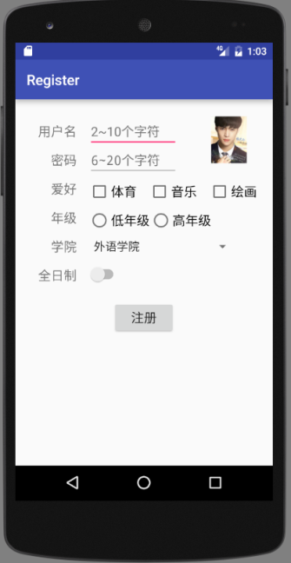 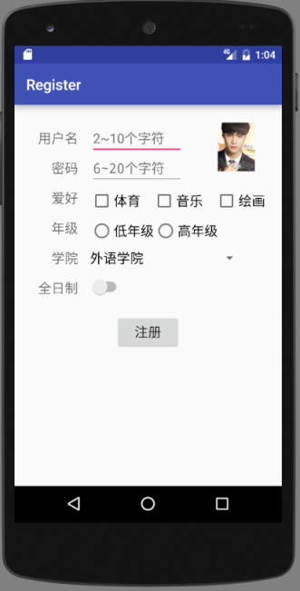 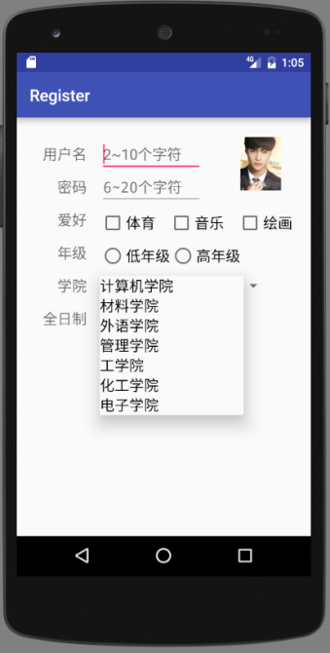

（Spinner默认字体） （Spinner字体变大 18sp）

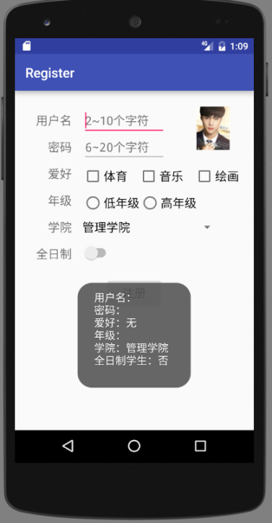 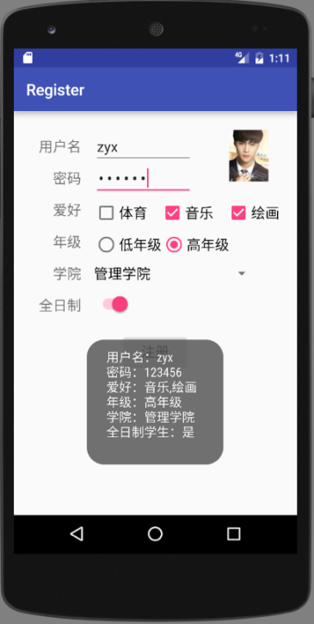

(输入为空时点击**注册按钮**) (输入不为空时点击**注册按钮**)

全部完成后的运行截屏：

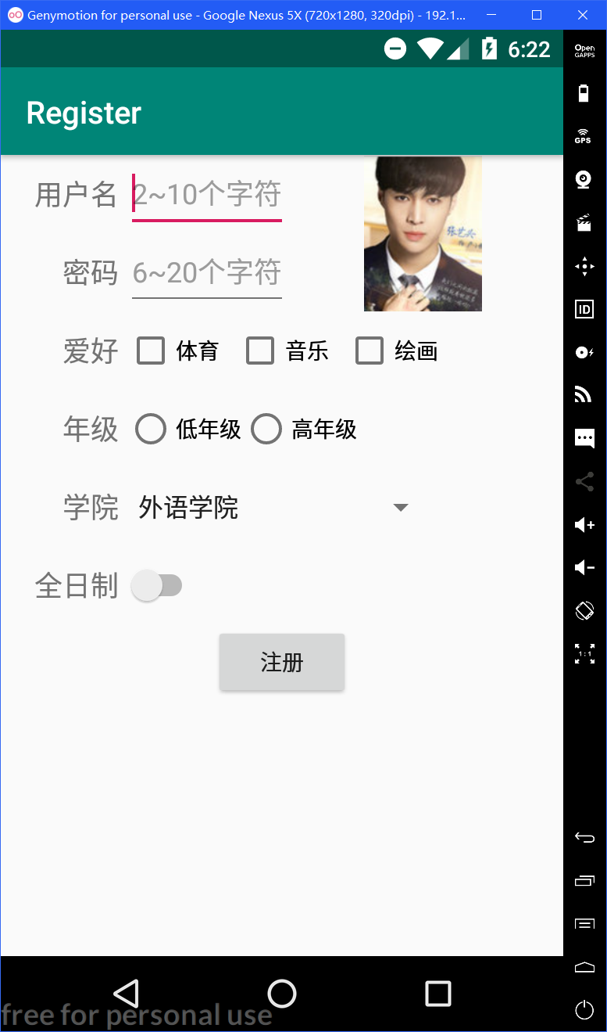 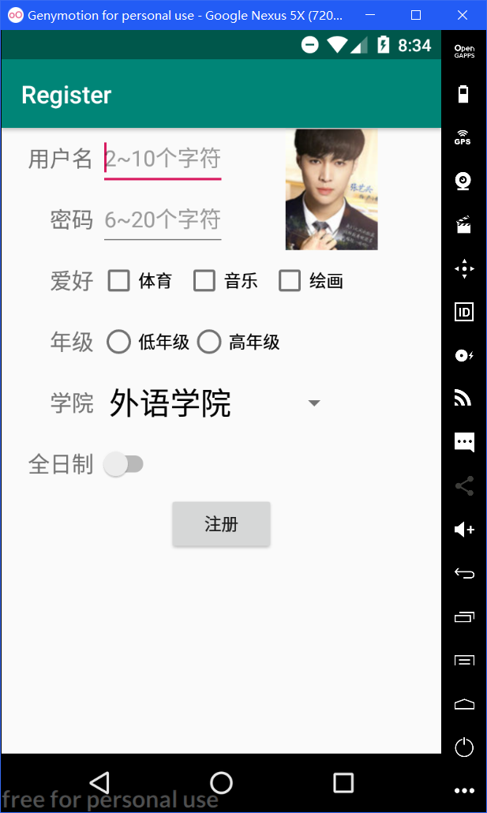 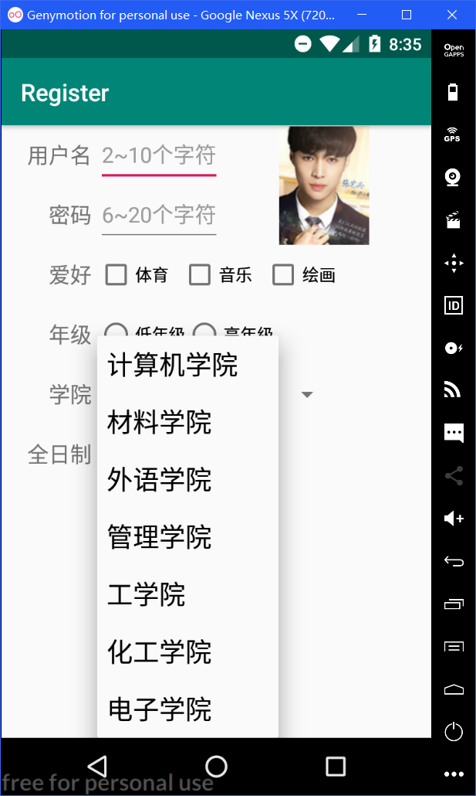

（Spinner默认字体） （Spinner字体变大）

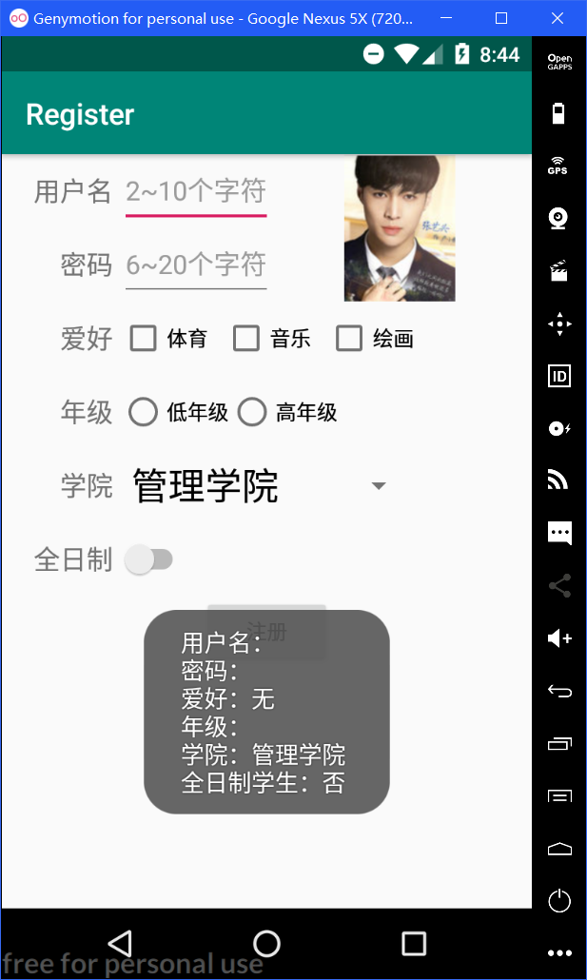 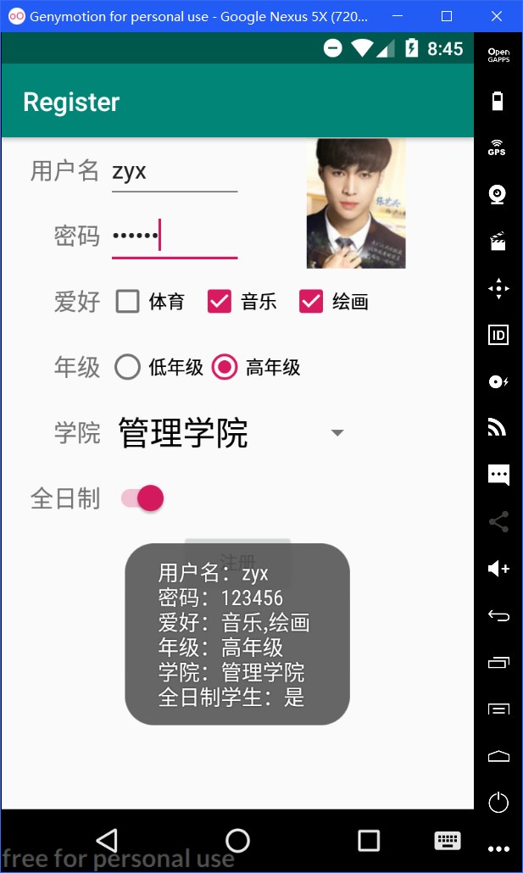

(输入为空时点击**注册按钮**) (输入不为空时点击**注册按钮**)

全部完成后源码(.java和.xml)：

activity_main.xml：

<?xml version="1.0" encoding="utf-8"?>

<RelativeLayout

xmlns:android="http://schemas.android.com/apk/res/android"

android:id="@+id/_main"

android:layout_width="match_parent"

android:layout_height="match_parent">

<TextView

android:layout_width="80dp"

android:layout_height="50dp"

android:gravity="right|center_vertical"

android:layout_alignParentLeft="true"

android:text="用户名 "

android:textSize="18sp"

android:id="@+id/yonghuming"/>

<EditText

android:layout_width="wrap_content"

android:layout_height="50dp"

android:hint="2~10个字符"

android:textSize="18sp"

android:layout_toRightOf="@id/yonghuming"

android:layout_alignTop="@id/yonghuming"

android:id="@+id/yhm_input"/>

<ImageView

android:scaleType="centerInside"

android:layout_width="180dp"

android:layout_height="100dp"

android:layout_alignParentRight="true"

android:id="@+id/imageview"

android:src="@drawable/zyx"

/>

<TextView

android:layout_width="80dp"

android:layout_height="50dp"

android:gravity="right|center_vertical"

android:text="密码 "

android:textSize="18sp"

android:layout_below="@id/yonghuming"

android:layout_alignRight="@id/yonghuming"

android:id="@+id/mima"/>

<EditText

android:layout_width="wrap_content"

android:layout_height="50dp"

android:hint="6~20个字符"

android:inputType="textPassword"

android:textSize="18sp"

android:layout_toRightOf="@id/mima"

android:layout_alignTop="@id/mima"

android:id="@+id/mima_input"/>

<TextView

android:layout_width="80dp"

android:layout_height="50dp"

android:gravity="right|center_vertical"

android:text="爱好 "

android:textSize="18sp"

android:layout_alignRight="@id/mima"

android:layout_below="@id/mima"

android:id="@+id/aihao"/>

<CheckBox

android:layout_width="70dp"

android:layout_height="50dp"

android:text="体育"

android:layout_toRightOf="@id/aihao"

android:layout_alignTop="@id/aihao"

android:checked="false"

android:id="@+id/checkbox1"/>

<CheckBox

android:layout_width="70dp"

android:layout_height="50dp"

android:text="音乐"

android:layout_toEndOf="@id/checkbox1"

android:layout_alignTop="@id/aihao"

android:checked="false"

android:id="@+id/checkbox2"/>

<CheckBox

android:layout_width="70dp"

android:layout_height="50dp"

android:text="绘画"

android:layout_toEndOf="@id/checkbox2"

android:layout_alignTop="@id/aihao"

android:checked="false"

android:id="@+id/checkbox3"/>

<TextView

android:layout_width="80dp"

android:layout_height="50dp"

android:gravity="right|center_vertical"

android:text="年级 "

android:textSize="18sp"

android:layout_alignRight="@id/aihao"

android:layout_below="@id/aihao"

android:id="@+id/nianji"/>

<RadioGroup

android:layout_width="wrap_content"

android:layout_height="wrap_content"

android:layout_toRightOf="@id/nianji"

android:layout_alignTop="@id/nianji"

android:orientation="horizontal"

android:id="@+id/radiogroup">

<RadioButton

android:layout_width="wrap_content"

android:layout_height="50dp"

android:text="低年级"

android:id="@+id/radiobutton1"/>

<RadioButton

android:layout_width="wrap_content"

android:layout_height="50dp"

android:text="高年级"

android:id="@+id/radiobutton2"/>

</RadioGroup>

<TextView

android:layout_width="80dp"

android:layout_height="50dp"

android:gravity="right|center_vertical"

android:text="学院 "

android:textSize="18sp"

android:layout_alignRight="@id/nianji"

android:layout_below="@id/nianji"

android:id="@+id/xueyuan"/>

<Spinner

android:layout_width="200dp"

android:layout_height="50dp"

android:layout_toRightOf="@id/xueyuan"

android:layout_alignTop="@id/xueyuan"

android:id="@+id/spinner"

android:entries="@array/xueyuan"

android:spinnerMode="dropdown"/>

<TextView

android:layout_width="80dp"

android:layout_height="50dp"

android:gravity="right|center_vertical"

android:text="全日制 "

android:textSize="18sp"

android:layout_below="@id/xueyuan"

android:layout_alignRight="@id/xueyuan"

android:id="@+id/quanrizhi"/>

<Switch

android:layout_width="wrap_content"

android:layout_height="50dp"

android:layout_alignTop="@id/quanrizhi"

android:layout_toRightOf="@id/quanrizhi"

android:id="@+id/switch1"

android:checked="false"/>

<Button

android:id="@+id/button"

android:layout_width="wrap_content"

android:layout_height="wrap_content"

android:layout_below="@id/quanrizhi"

android:layout_centerHorizontal="true"

android:text="注册" />

</RelativeLayout>

MainAcitivity.java：

package com.example.register;

import android.support.v7.app.AppCompatActivity;

import android.os.Bundle;

import android.view.View;

import android.widget.Button;

import android.widget.EditText;

import android.widget.CheckBox;

import android.view.View.OnClickListener;

import android.widget.RadioButton;

import android.widget.Spinner;

import android.widget.Switch;

import android.widget.Toast;

public class MainActivity extends AppCompatActivity {

Button btn;

CheckBox chk[];

RadioButton rdb[];

EditText editText1, editText2;

Switch switch1;

Spinner spinner;

String mstringarray[];

@Override

protected void onCreate(Bundle savedInstanceState) {

super.onCreate(savedInstanceState);

setContentView(R.layout.activity_main);

editText1 = (EditText) findViewById(R.id.yhm_input);

editText2 = (EditText) findViewById(R.id.mima_input);

chk = new CheckBox[3];

chk[0] = (CheckBox) findViewById(R.id.checkbox1);

chk[1] = (CheckBox) findViewById(R.id.checkbox2);

chk[2] = (CheckBox) findViewById(R.id.checkbox3);

rdb = new RadioButton[2];

rdb[0] = (RadioButton) findViewById(R.id.radiobutton1);

rdb[1] = (RadioButton) findViewById(R.id.radiobutton2);

spinner = (Spinner) findViewById(R.id.spinner);

mstringarray = getResources().getStringArray(R.array.xueyuan);

ArrayAdapter<String> madapter = new testarrayadapter(this, mstringarray);

spinner.setAdapter(madapter);

switch1 = (Switch) findViewById(R.id.switch1);

btn = (Button) findViewById(R.id.button);

btn.setOnClickListener(new OnClickListener() {

@Override

public void onClick(View view) {

String str1 = editText1.getText().toString();

String str2 = editText2.getText().toString();

String checkbox_str = "";

if (chk[0].isChecked())

checkbox_str += chk[0].getText() + ",";

if (chk[1].isChecked())

checkbox_str += chk[1].getText() + ",";

if (chk[2].isChecked())

checkbox_str += chk[2].getText() + ",";

if (checkbox_str.isEmpty())

checkbox_str = "无";

else

checkbox_str = checkbox_str.substring(0, checkbox_str.length() - 1);

String nianji = "";

if (rdb[0].isChecked())

nianji = rdb[0].getText().toString();

else if (rdb[1].isChecked())

nianji = rdb[1].getText().toString();

String xueyuan = (String) spinner.getSelectedItem();

String output = "用户名：" + str1 + '\n' + "密码：" + str2 + '\n' + "爱好：" + checkbox_str + '\n' + "年级：" + nianji + '\n' + "学院：" + xueyuan + '\n' + "全日制学生：";

if (switch1.isChecked())

output += "是";

else

output += "否";

Toast toast = Toast.makeText(getApplicationContext(), output, Toast.LENGTH_LONG);

toast.show();

}

});

}

}

testarrayadapter.java：

package com.example.register;

import android.content.Context;

import android.view.LayoutInflater;

import android.view.View;

import android.view.ViewGroup;

import android.widget.ArrayAdapter;

import android.widget.TextView;

public class testarrayadapter extends ArrayAdapter<String> {

Context mcontext;

String mstringarray[];

public testarrayadapter(Context context, String[] stringarray) {

super(context, android.R.layout.simple_spinner_item, stringarray);

mcontext = context;

mstringarray = stringarray;

}

@Override

public View getDropDownView(int position, View convertview, ViewGroup parent) {

if (convertview == null) {

LayoutInflater inflater = LayoutInflater.from(mcontext);

convertview = inflater.inflate(android.R.layout.simple_spinner_dropdown_item, parent, false);

}

TextView tv = (TextView) convertview.findViewById(android.R.id.text1);

tv.setText(mstringarray[position]);

tv.setTextSize(22f);

return convertview;

}

@Override

public View getView(int position, View convertview, ViewGroup parent) {

if (convertview == null) {

LayoutInflater inflater = LayoutInflater.from(mcontext);

convertview = inflater.inflate(android.R.layout.simple_spinner_dropdown_item, parent, false);

}

TextView tv = (TextView) convertview.findViewById(android.R.id.text1);

tv.setText(mstringarray[position]);

tv.setTextSize(25f);

return convertview;

}

}

arrays.xml：

<?xml version="1.0" encoding="utf-8"?>

<resources>

<string-array name="xueyuan">

<item>计算机学院</item>

<item>材料学院</item>

<item>外语学院</item>

<item>管理学院</item>

<item>工学院</item>

<item>化工学院</item>

<item>电子学院</item>

</string-array>

</resources>

2、（GridViewSimple）做一个GridView画面（参考ListBoxSimple），要做长短点击事件，采用相对布局。

参考运行截屏：

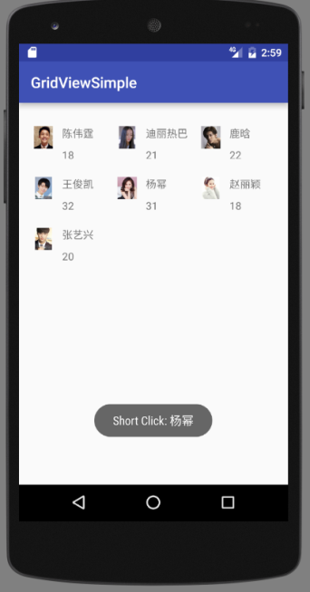 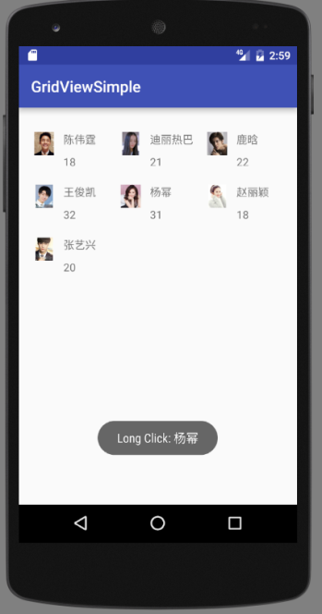

全部完成后的运行截屏：

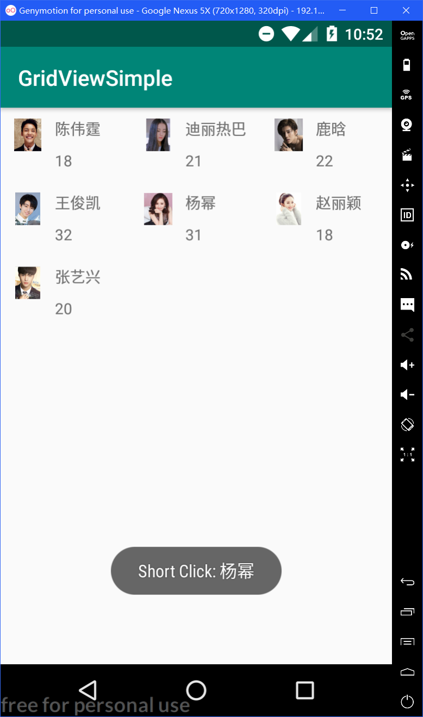 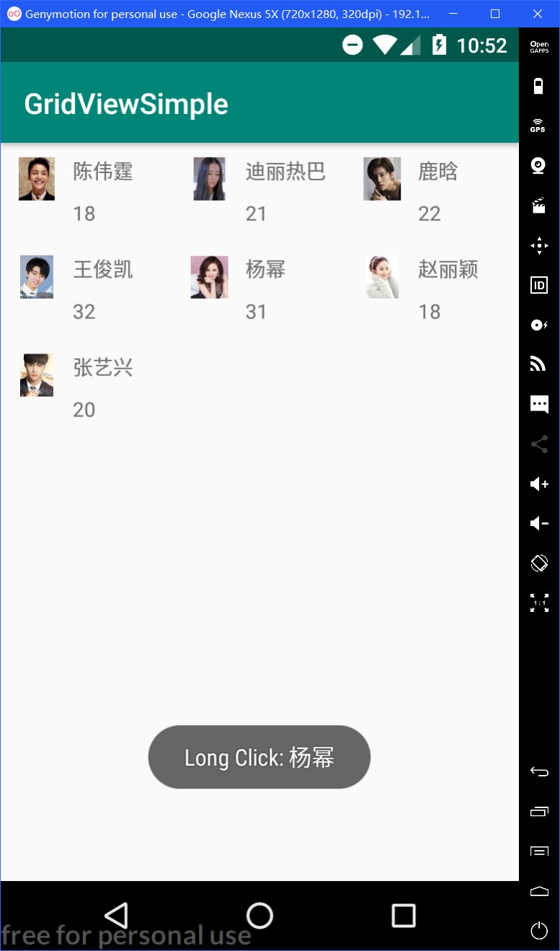

全部完成后源码(.java和.xml)：

MainAcivity.java：

package com.example.gridviewsimple;

import android.support.v7.app.AppCompatActivity;

import android.os.Bundle;

import android.view.View;

import android.widget.AdapterView;

import android.widget.GridView;

import android.widget.SimpleAdapter;

import android.widget.Toast;

import java.util.ArrayList;

import java.util.HashMap;

import java.util.Map;

public class MainActivity extends AppCompatActivity {

GridView gridView;

int[] images = {R.drawable.cwt, R.drawable.dlrb, R.drawable.lh, R.drawable.wjk, R.drawable.ym, R.drawable.zly, R.drawable.zyx};

String[] names = {"陈伟霆", "迪丽热巴", "鹿晗", "王俊凯", "杨幂", "赵丽颖", "张艺兴"};

int[] ages = {18, 21, 22, 32, 31, 18, 20};

ArrayList list = new ArrayList<Map<String, Object>>();

@Override

protected void onCreate(Bundle savedInstanceState) {

super.onCreate(savedInstanceState);

setContentView(R.layout.activity_main);

for (int i = 0; i < names.length; i++) {

Map<String, Object> map = new HashMap<String, Object>();

map.put("icon", images[i]);

map.put("name", names[i]);

map.put("age", ages[i]);

list.add(map);

}

gridView = (GridView) findViewById(R.id.gridview);

SimpleAdapter adapter = new SimpleAdapter(this, list, R.layout.picture_item, new String[]{"icon", "name", "age"}, new int[]{R.id.icon, R.id.name, R.id.age});

gridView.setAdapter(adapter);

gridView.setOnItemClickListener(new AdapterView.OnItemClickListener() {

@Override

public void onItemClick(AdapterView<?> adapterView, View view, int i, long l) {

String output = list.get(i).toString();

output = "Short Click: " + output.substring(output.indexOf('=') + 1, output.indexOf(','));

Toast.makeText(getApplicationContext(), output, Toast.LENGTH_SHORT).show();

}

});

gridView.setOnItemLongClickListener(new AdapterView.OnItemLongClickListener() {

@Override

public boolean onItemLongClick(AdapterView<?> adapterView, View view, int i, long l) {

String output = list.get(i).toString();

output = "Long Click: " + output.substring(output.indexOf('=') + 1, output.indexOf(','));

Toast.makeText(getApplicationContext(), output, Toast.LENGTH_SHORT).show();

return true;

}

});

}

}

activity_main.xml：

<?xml version="1.0" encoding="utf-8"?>

<RelativeLayout xmlns:android="http://schemas.android.com/apk/res/android"

xmlns:tools="http://schemas.android.com/tools"

android:layout_width="match_parent"

android:layout_height="match_parent"

tools:context=".MainActivity">

<GridView

android:id="@+id/gridview"

android:layout_width="match_parent"

android:layout_height="match_parent"

android:columnWidth="120dp"

android:stretchMode="none"

android:numColumns="3"/>

</RelativeLayout>

picture_item.xml：

<?xml version="1.0" encoding="utf-8"?>

<RelativeLayout xmlns:android="http://schemas.android.com/apk/res/android"

android:layout_width="match_parent"

android:layout_height="match_parent"

android:padding="10dp">

<ImageView

android:layout_width="30dp"

android:layout_height="30dp"

android:id="@+id/icon"

android:src="@drawable/cwt"

android:layout_marginRight="10dp"/>

<TextView

android:layout_width="wrap_content"

android:layout_height="wrap_content"

android:id="@+id/name"

android:text="姓名"

android:layout_toRightOf="@id/icon"/>

<TextView

android:layout_width="wrap_content"

android:layout_height="wrap_content"

android:id="@+id/age"

android:text="年龄"

android:layout_below="@id/name"

android:layout_marginTop="10dp"

android:layout_alignLeft="@id/name"/>

</RelativeLayout>

3、（Chronometer）利用安卓的控件Chronometer（使用方法自己上网查）做一个秒表，要求采用相对布局：

（1）启动后开始计时

（2）按暂停键暂停计时

（3）按重置键重新计时

参考函数：String.format("%02d:02d",i,j)

参考运行屏幕：

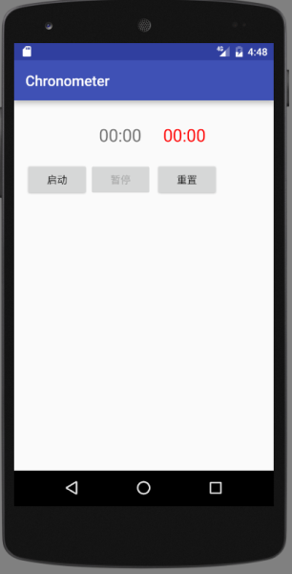 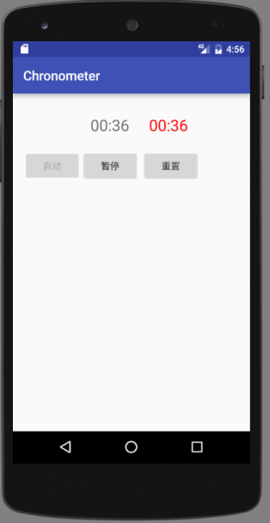 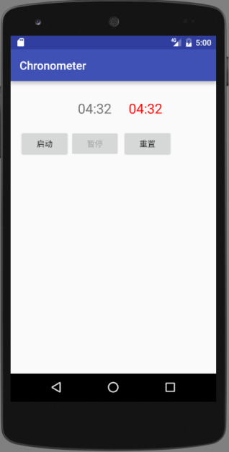

（开始和重置后） （按启动键） （按暂停键—停止走表）

红色字是Chronometer显示出来的

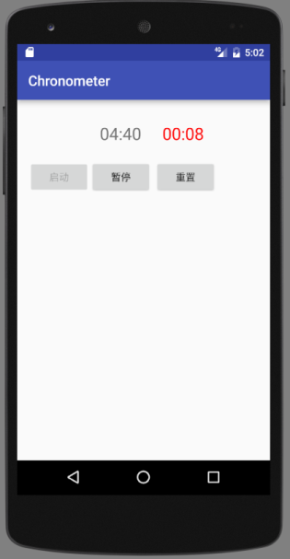 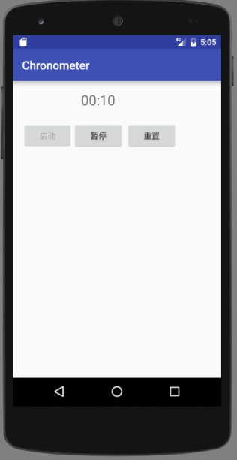

（再按启动键） （隐藏Chronometer:  
visibility:gone|invisible）

全部完成后的运行截屏：

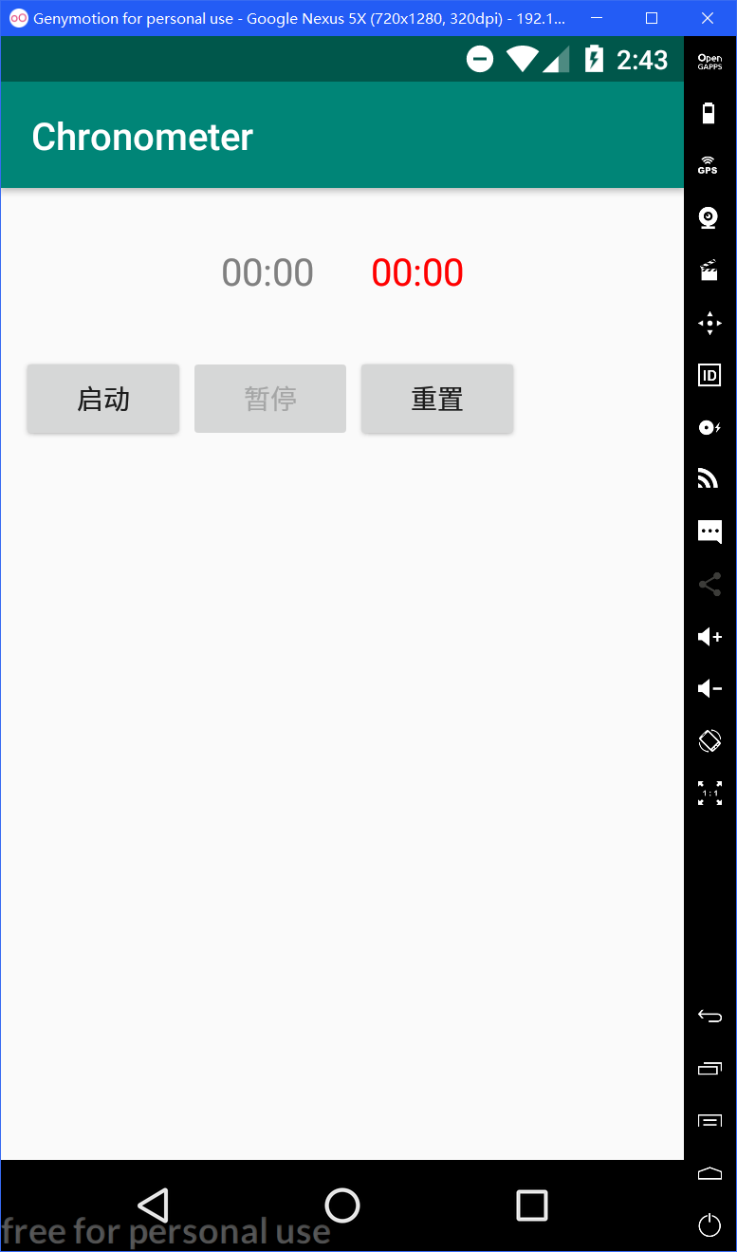 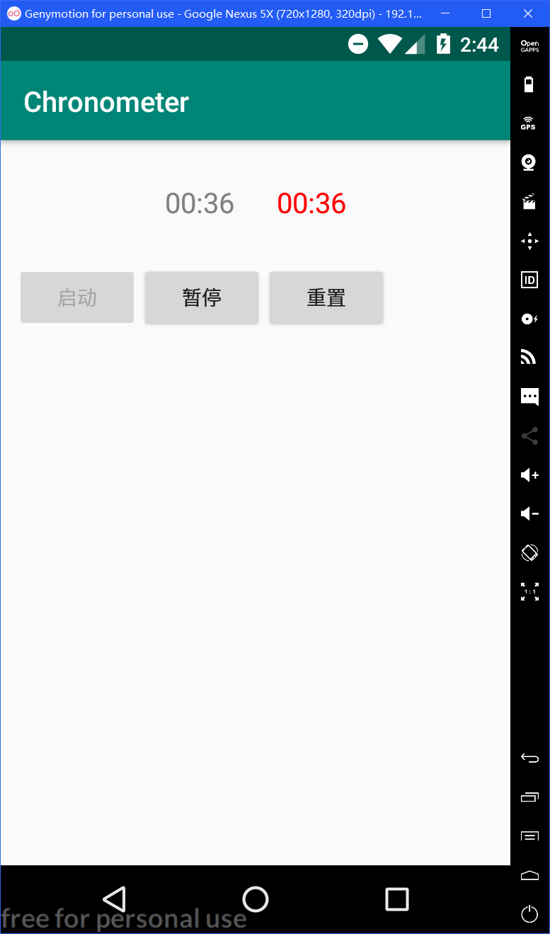 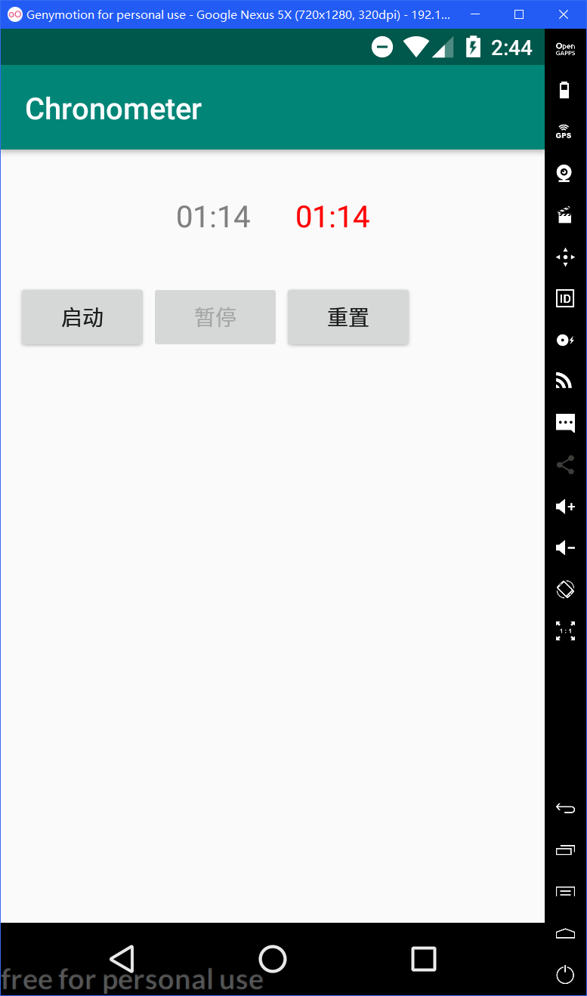

（开始和重置后） （按启动键） （按暂停键—停止走表）

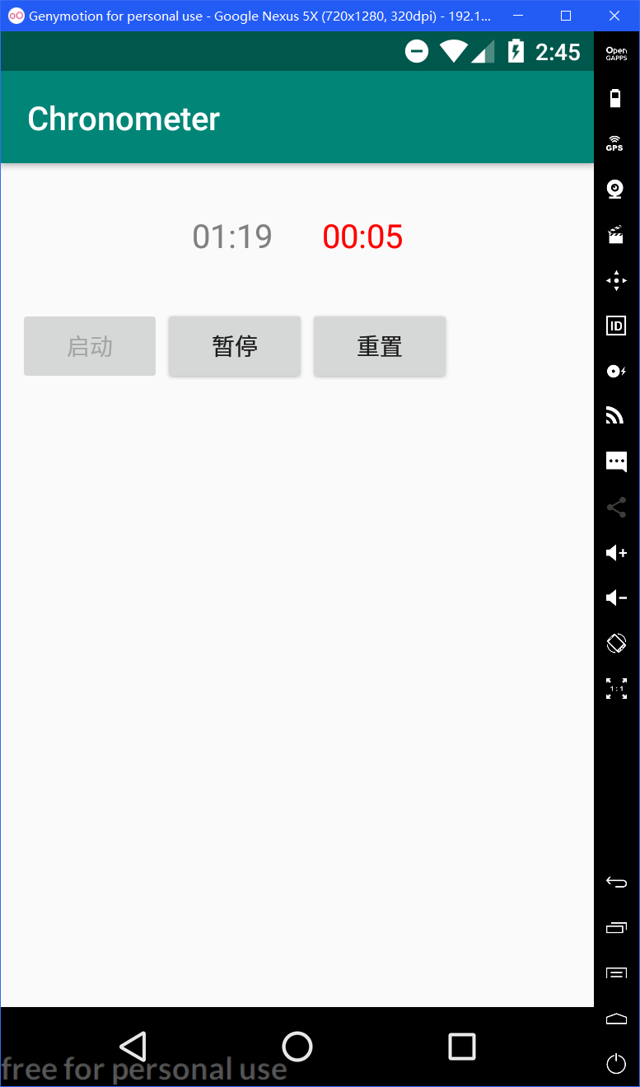 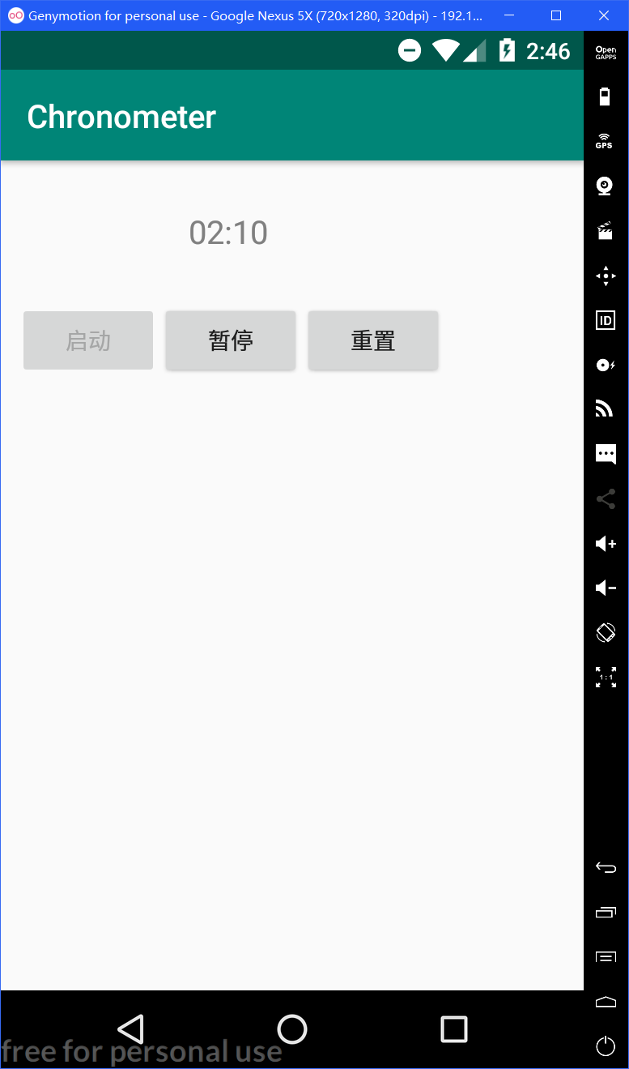

（再按启动键） （点击右侧计时器，隐藏Chronometer:visibility:gone|invisible）

全部完成后源码(.java和.xml)：

MainAcitivity.java：

package com.example.chronometer;

import android.os.SystemClock;

import android.support.v7.app.AppCompatActivity;

import android.os.Bundle;

import android.widget.Button;

import android.widget.Chronometer;

import android.view.View;

public class MainActivity extends AppCompatActivity implements View.OnClickListener{

Chronometer chronometer1, chronometer2;

Button button1, button2, button3;

long stoptime = 0;

@Override

protected void onCreate(Bundle savedInstanceState) {

super.onCreate(savedInstanceState);

setContentView(R.layout.activity_main);

chronometer1 = (Chronometer) findViewById(R.id.chronometer1);

chronometer2 = (Chronometer) findViewById(R.id.chronometer2);

button1 = (Button) findViewById(R.id.start);

button2 = (Button) findViewById(R.id.stop);

button3 = (Button) findViewById(R.id.reset);

button2.setEnabled(false);

button1.setOnClickListener(this);

button2.setOnClickListener(this);

button3.setOnClickListener(this);

chronometer2.setOnClickListener(this);

}

@Override

public void onClick(View v) {

switch (v.getId()) {

case R.id.start:

if (stoptime == 0) {

chronometer1.setBase(SystemClock.elapsedRealtime());

chronometer2.setBase(SystemClock.elapsedRealtime());

chronometer1.start();

chronometer2.start();

}

else {

chronometer1.setBase(chronometer1.getBase() + (SystemClock.elapsedRealtime() - stoptime));

chronometer1.start();

chronometer2.setBase(SystemClock.elapsedRealtime());

chronometer2.start();

}

button1.setEnabled(false);

button2.setEnabled(true);

break;

case R.id.stop:

stoptime = SystemClock.elapsedRealtime();

chronometer1.stop();

chronometer2.stop();

button1.setEnabled(true);

button2.setEnabled(false);

break;

case R.id.reset:

stoptime = 0;

chronometer1.setBase(SystemClock.elapsedRealtime());

chronometer2.setBase(SystemClock.elapsedRealtime());

chronometer1.stop();

chronometer2.stop();

button1.setEnabled(true);

button2.setEnabled(false);

break;

case R.id.chronometer2:

chronometer2.setVisibility(View.INVISIBLE);

}

}

}

Activity_main.xml：

<?xml version="1.0" encoding="utf-8"?>

<RelativeLayout xmlns:android="http://schemas.android.com/apk/res/android"

android:layout_width="match_parent"

android:layout_height="match_parent">

<LinearLayout

android:layout_width="wrap_content"

android:layout_height="wrap_content"

android:layout_marginTop="30dp"

android:layout_centerHorizontal="true"

android:orientation="horizontal"

android:id="@+id/linear">

<Chronometer

android:layout_width="wrap_content"

android:layout_height="wrap_content"

android:id="@+id/chronometer1"

android:textSize="20sp"

android:textColor="@color/grey"

android:layout_marginRight="30dp"/>

<Chronometer

android:layout_width="wrap_content"

android:layout_height="wrap_content"

android:id="@+id/chronometer2"

android:textSize="20sp"

android:textColor="@color/red"/>

</LinearLayout>

<LinearLayout

android:layout_width="wrap_content"

android:layout_height="wrap_content"

android:orientation="horizontal"

android:layout_below="@id/linear"

android:layout_marginTop="30dp"

android:layout_marginLeft="10dp">

<Button

android:layout_width="wrap_content"

android:layout_height="wrap_content"

android:id="@+id/start"

android:text="启动"/>

<Button

android:layout_width="wrap_content"

android:layout_height="wrap_content"

android:id="@+id/stop"

android:text="暂停"/>

<Button

android:layout_width="wrap_content"

android:layout_height="wrap_content"

android:id="@+id/reset"

android:text="重置"/>

</LinearLayout>

</RelativeLayout>

4、（Calculator）做一个简单计算器，可以参考Windows计算器，要求用线性布局(LinearLayout)，控件使用TextView和Button。符号：＋－×÷←.±。

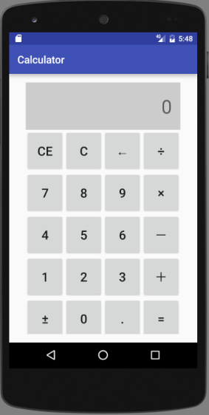 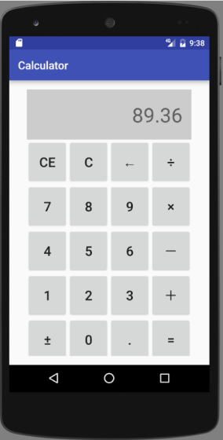 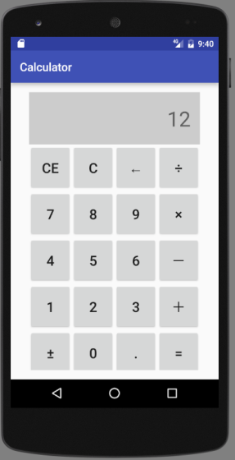

初始 输入一个数 输入X和12

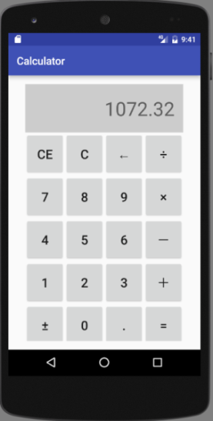 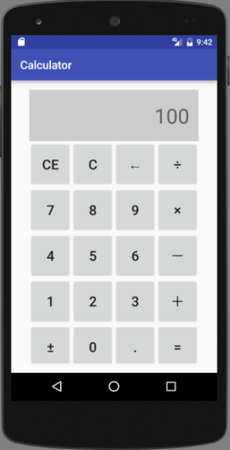 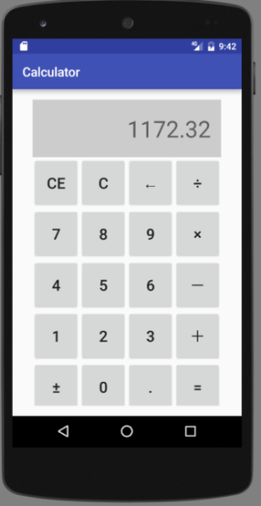

按+号后 输入100 按=号后

（1）对所有控件进行布局。要求全部采用线性布局。

（2）完成数字和小数点输入。注意处理按了多次小数点的情况。

（3）（选做）完成+-*/=操作。运算结果不能被修改。

（4）（选做）其他功能：CE、C、←（删除）、±

全部完成后按步骤操作的运行截屏：

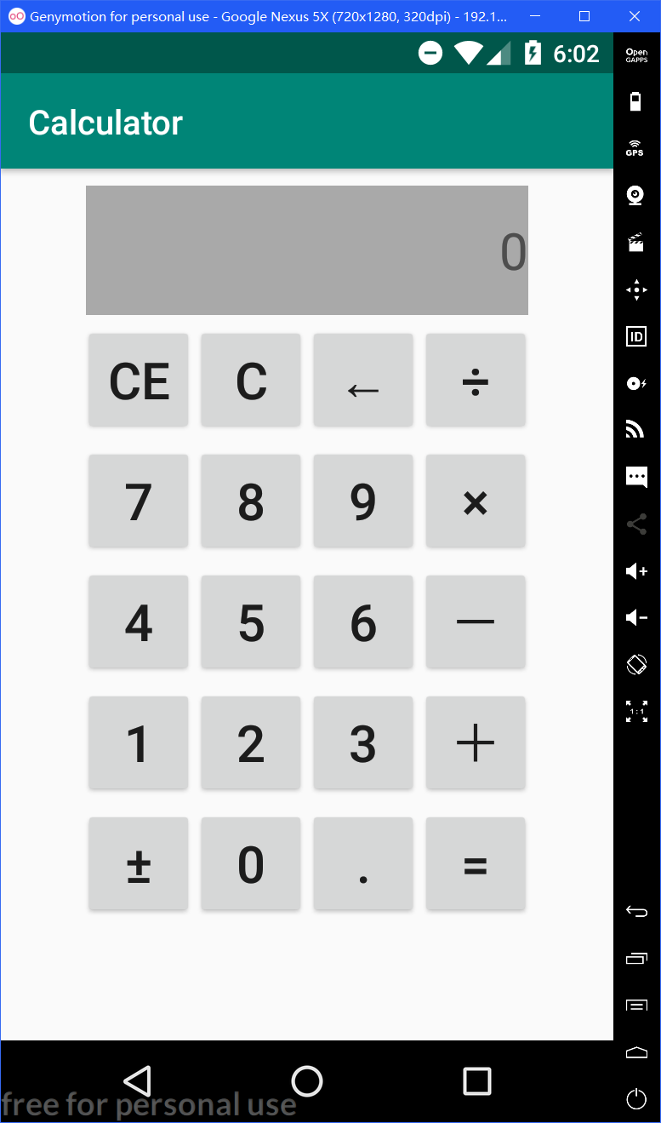 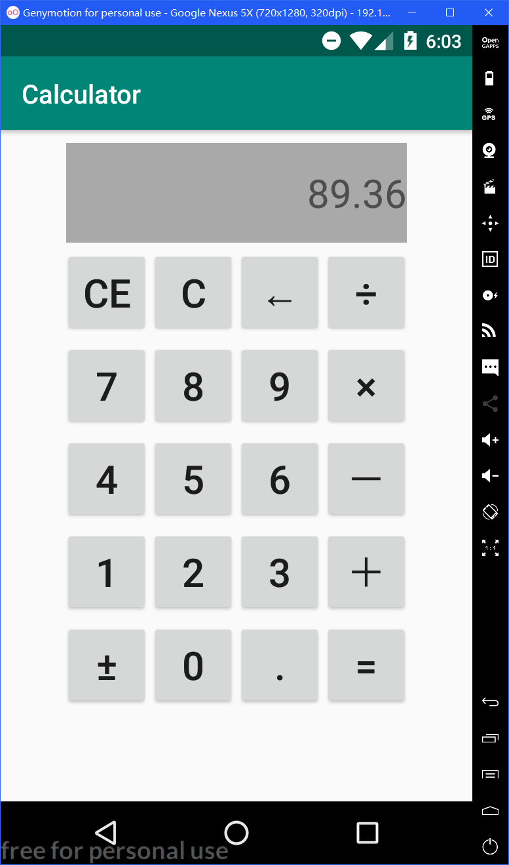 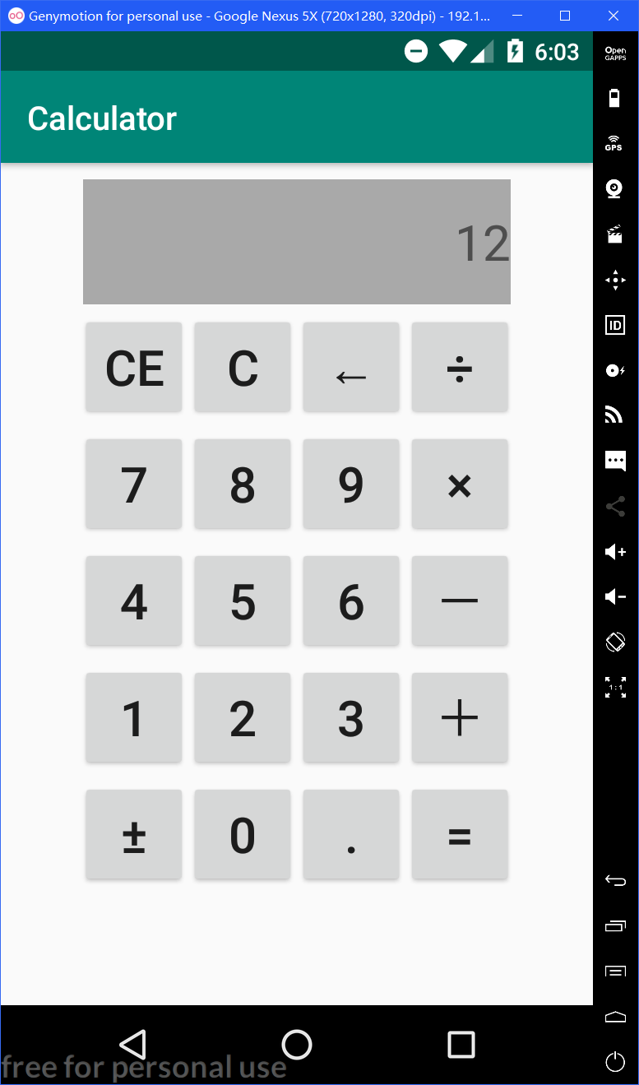

初始 输入一个数 输入X和12

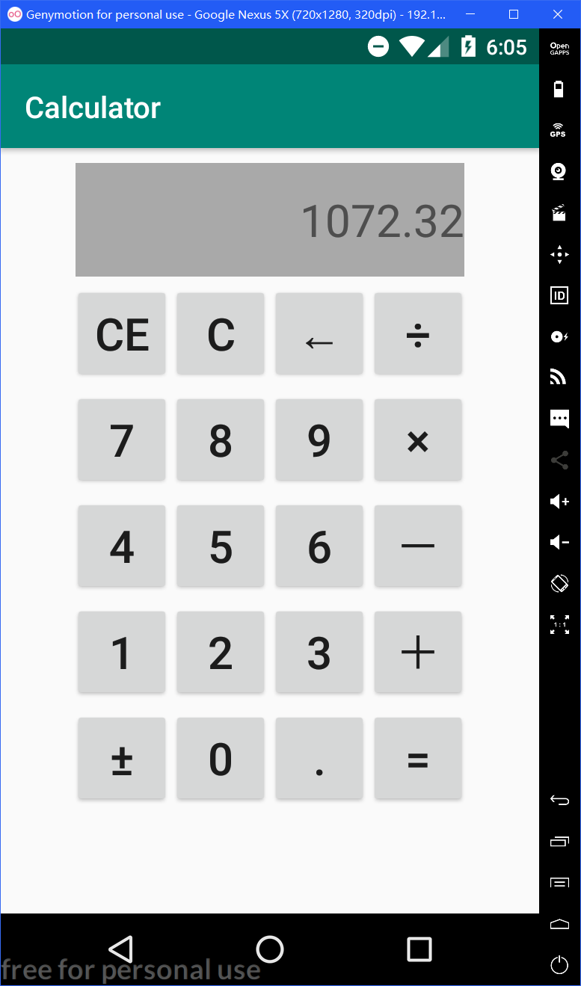 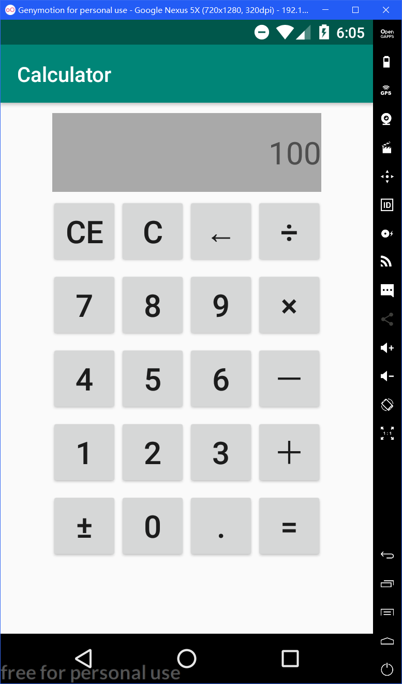 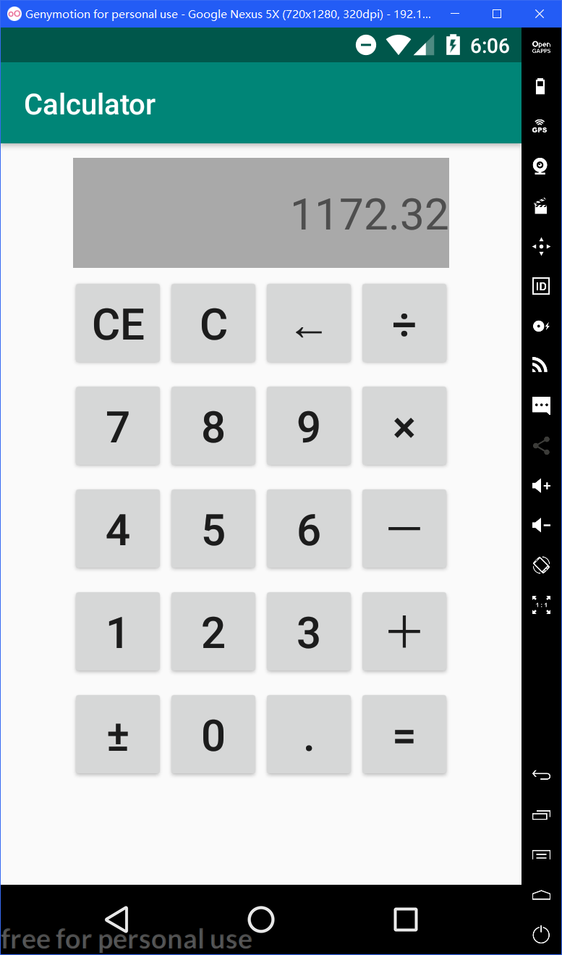

按+号后 输入100 按=号后

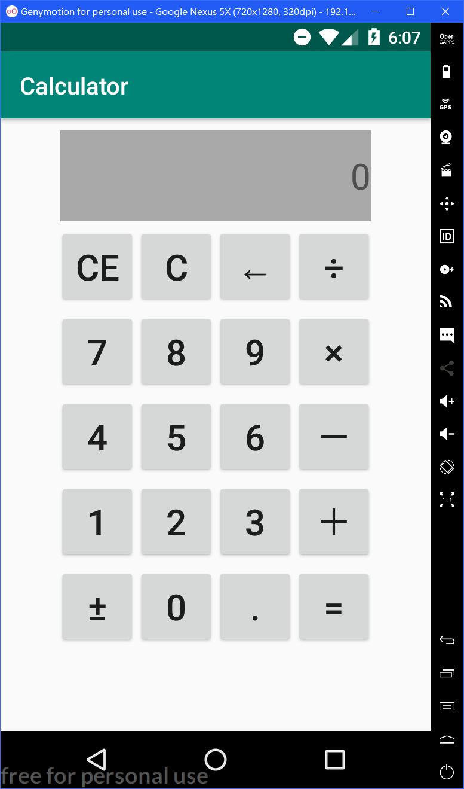 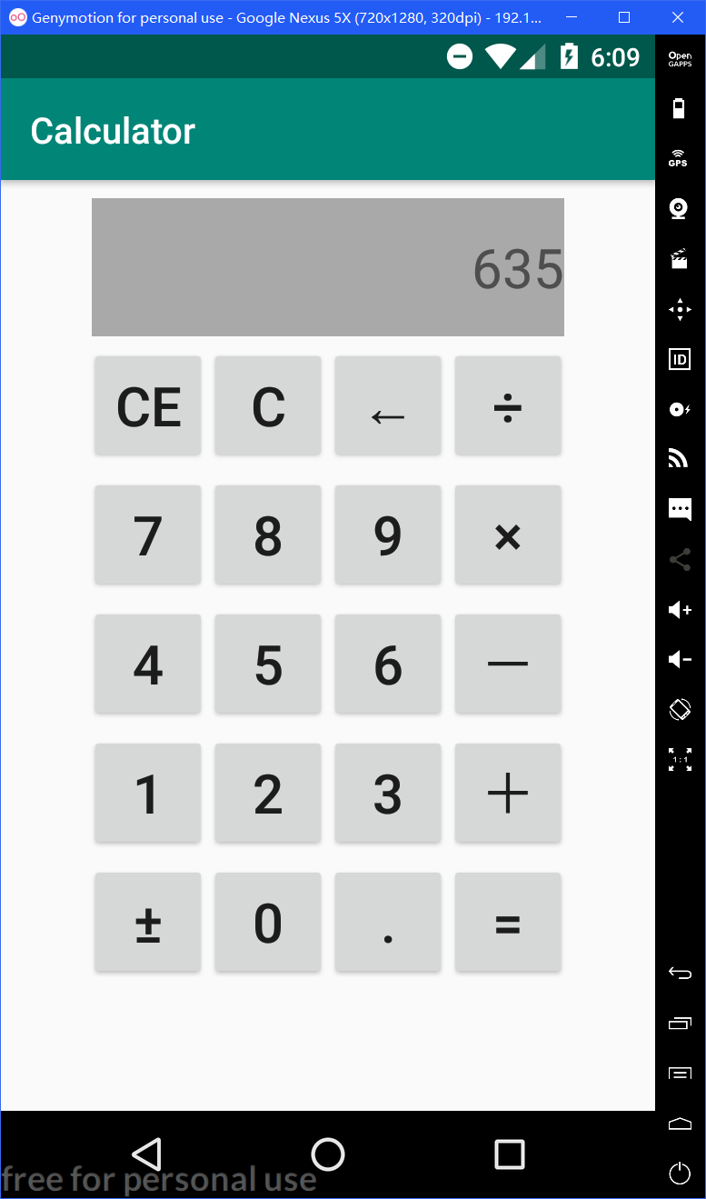 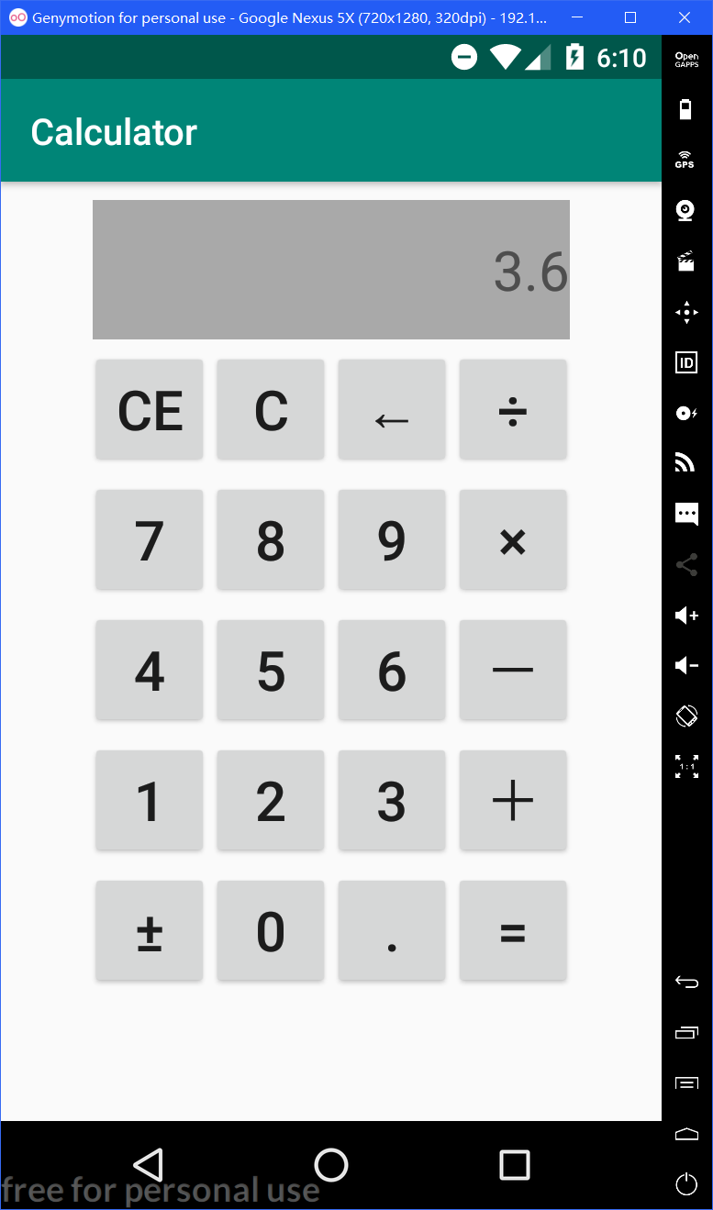

按C号后 输入一个数 输入-号和3.6

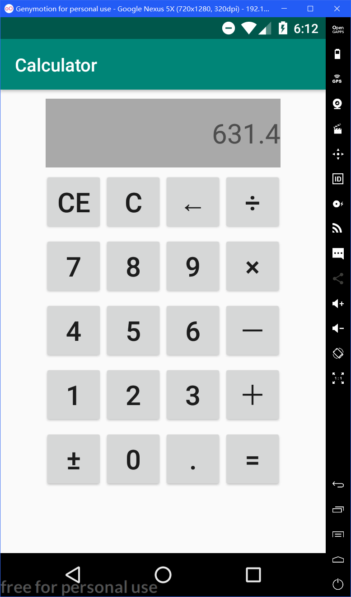 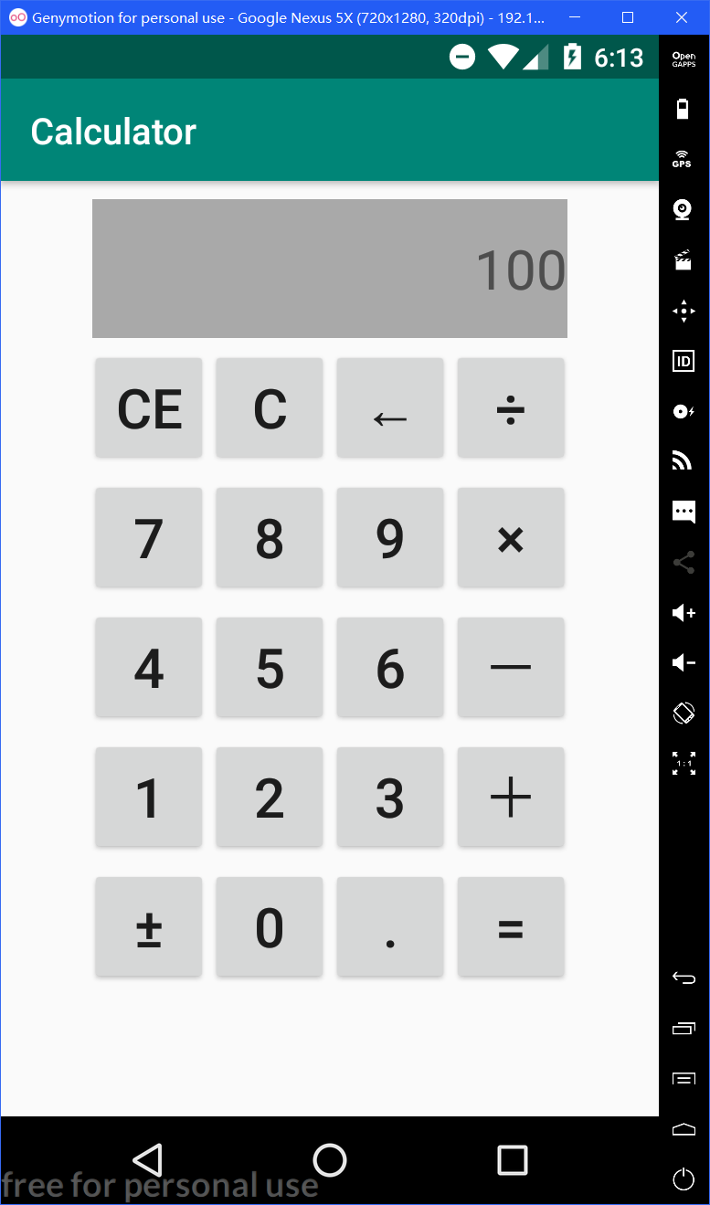 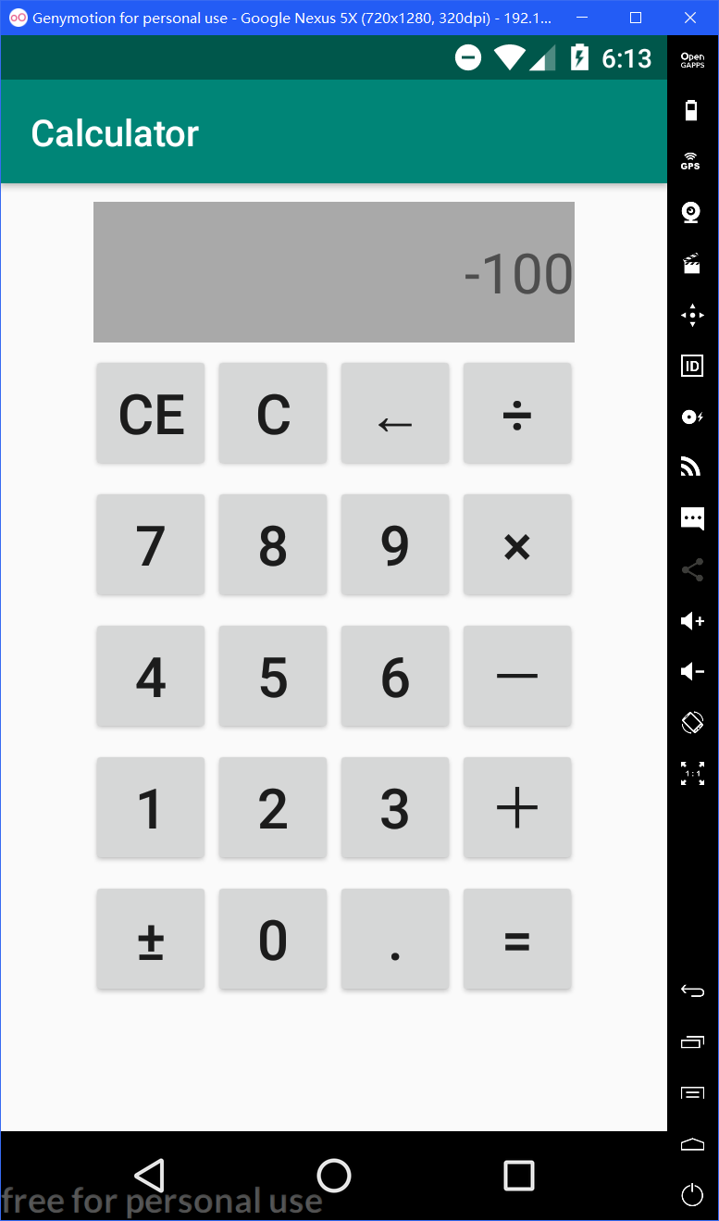

按÷号后 输入100 按±号后

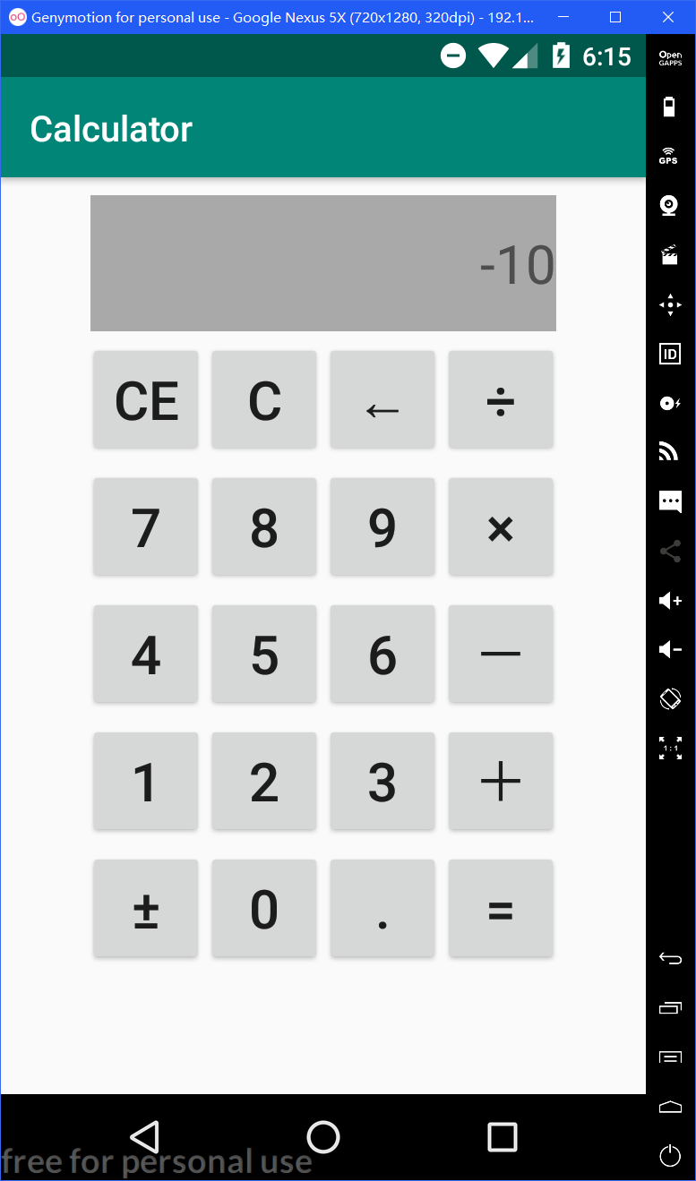 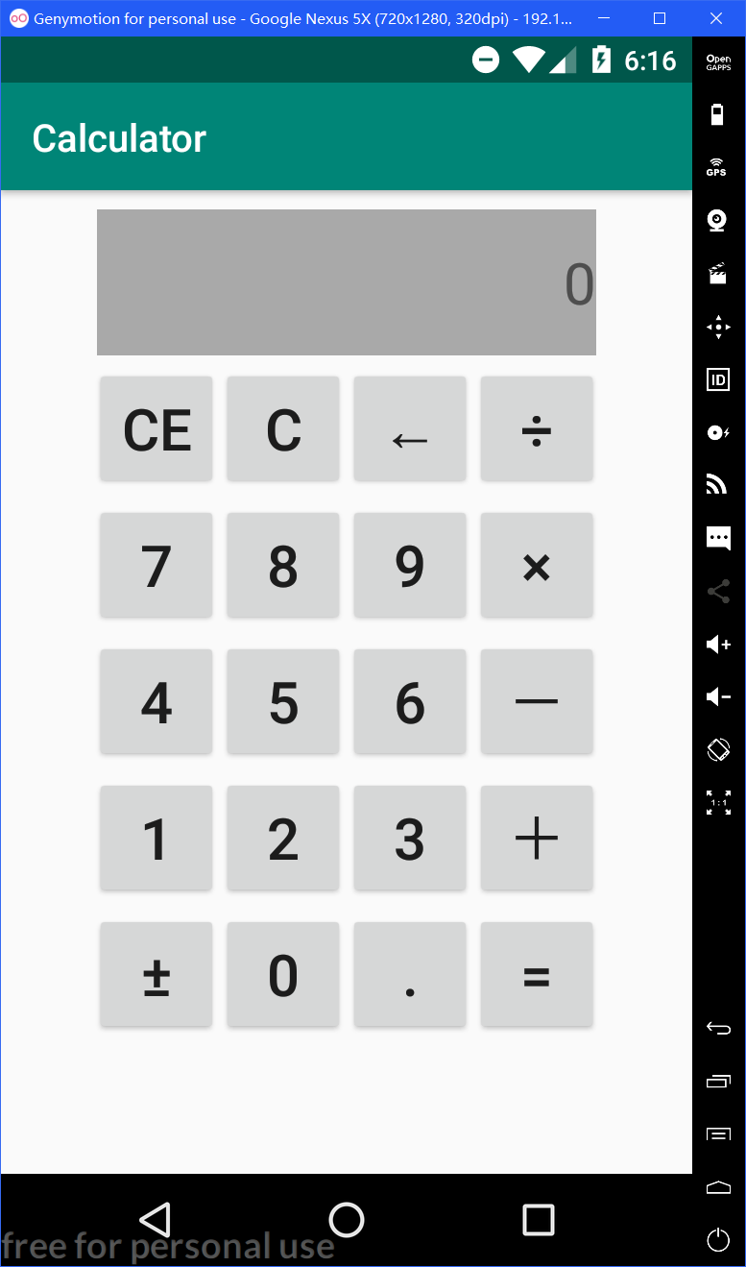 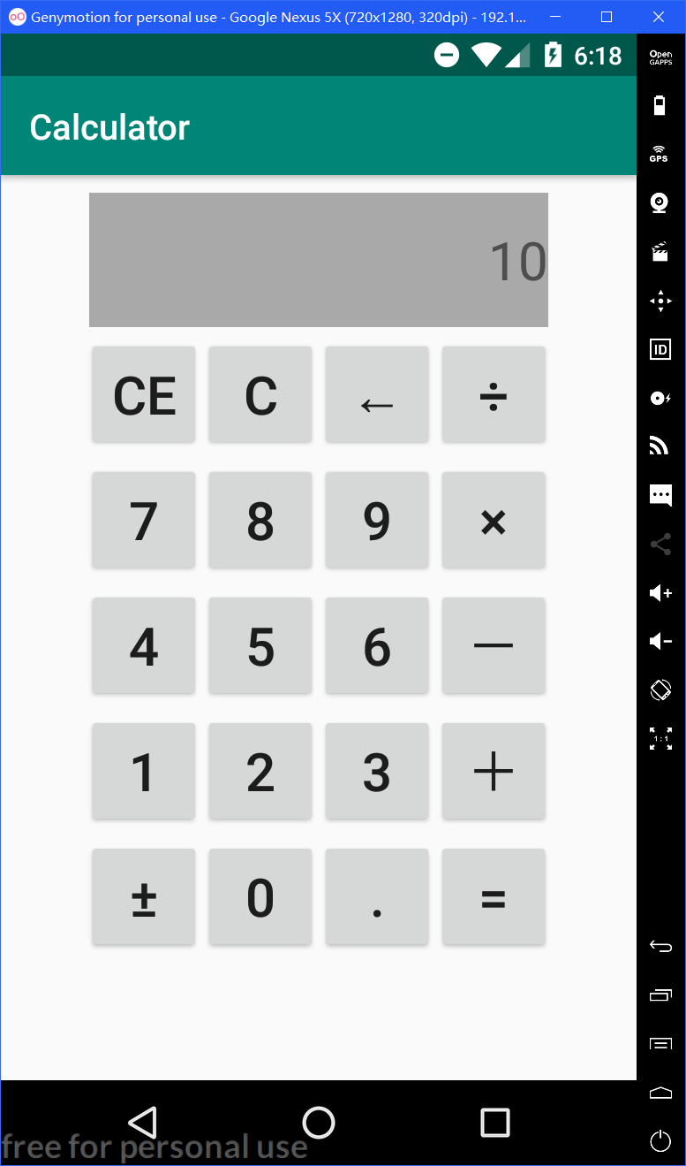

按←（删除）号后 按CE后 输入10

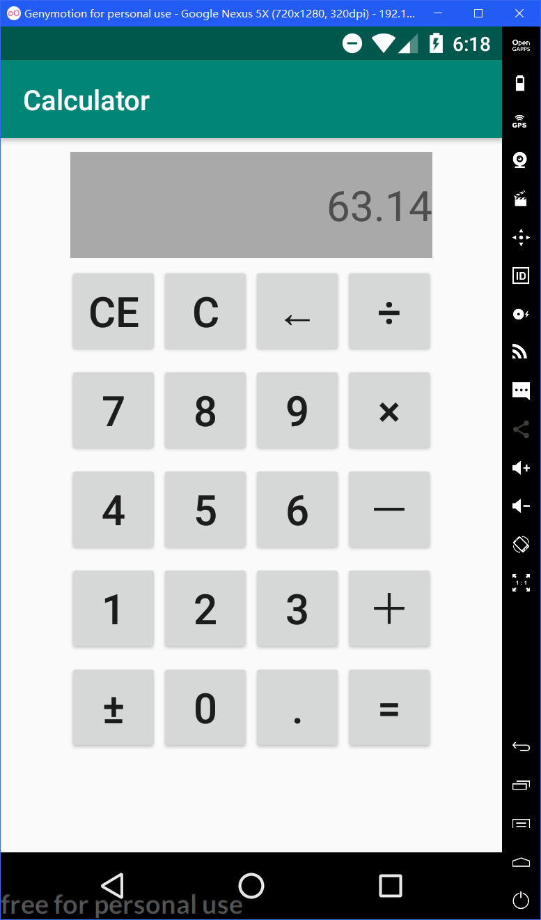 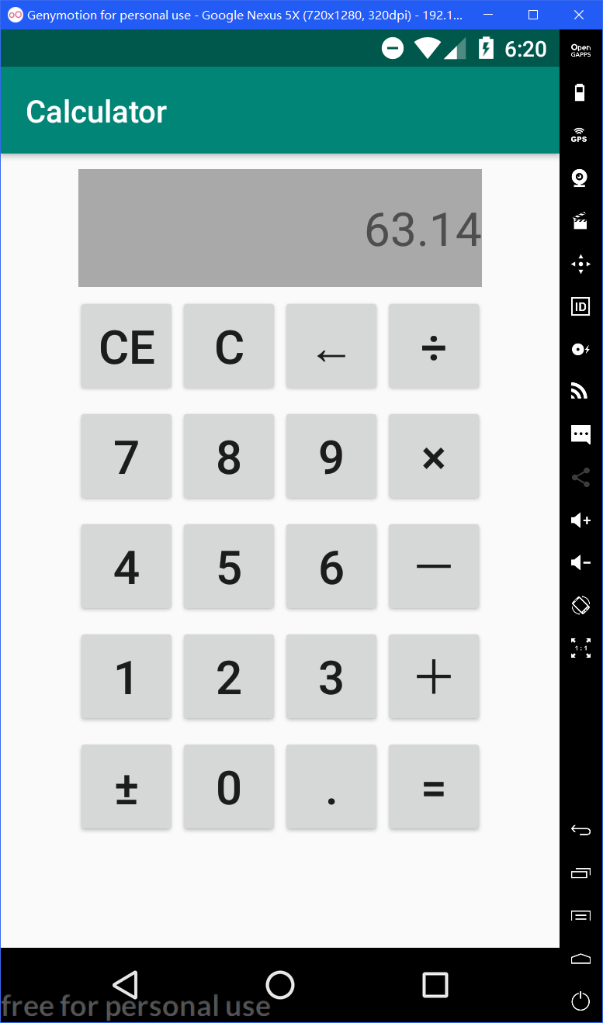

按=号后 除C键，其余键均不能修改运算结果

全部完成后源码(.java和.xml)：

MainActivity.java：

package com.example.calculator;

import android.icu.text.NumberFormat;

import android.support.v7.app.AppCompatActivity;

import android.os.Bundle;

import android.view.View;

import android.widget.Button;

import android.widget.EditText;

import android.widget.TextView;

public class MainActivity extends AppCompatActivity implements View.OnClickListener{

Button one, two, three, four, five, six, seven, eight, nine, zero, ce, c, backspace, div, mult, sub, add, equal, dot, sign;

TextView input;

double value = 0;

String str, op = "";

Boolean flag = false, disable = false;

@Override

protected void onCreate(Bundle savedInstanceState) {

super.onCreate(savedInstanceState);

setContentView(R.layout.activity_main);

one = (Button) findViewById(R.id.one);

two = (Button) findViewById(R.id.two);

three = (Button) findViewById(R.id.three);

four = (Button) findViewById(R.id.four);

five = (Button) findViewById(R.id.five);

six = (Button) findViewById(R.id.six);

seven = (Button) findViewById(R.id.seven);

eight = (Button) findViewById(R.id.eight);

nine = (Button) findViewById(R.id.nine);

zero = (Button) findViewById(R.id.zero);

ce = (Button) findViewById(R.id.ce);

c = (Button) findViewById(R.id.c);

backspace = (Button) findViewById(R.id.backspace);

div = (Button) findViewById(R.id.division);

mult = (Button) findViewById(R.id.multiply);

sub = (Button) findViewById(R.id.subtraction);

add = (Button) findViewById(R.id.addition);

equal = (Button) findViewById(R.id.equal);

dot = (Button) findViewById(R.id.dot);

sign = (Button) findViewById(R.id.sign);

input = (TextView) findViewById(R.id.yminput);

zero.setOnClickListener(this);

one.setOnClickListener(this);

two.setOnClickListener(this);

three.setOnClickListener(this);

four.setOnClickListener(this);

five.setOnClickListener(this);

six.setOnClickListener(this);

seven.setOnClickListener(this);

eight.setOnClickListener(this);

nine.setOnClickListener(this);

ce.setOnClickListener(this);

c.setOnClickListener(this);

backspace.setOnClickListener(this);

div.setOnClickListener(this);

mult.setOnClickListener(this);

sub.setOnClickListener(this);

add.setOnClickListener(this);

equal.setOnClickListener(this);

dot.setOnClickListener(this);

sign.setOnClickListener(this);

}

@Override

public void onClick(View v) {

str = input.getText().toString();

switch (v.getId()) {

case R.id.zero:

if (disable)

break;

if (flag)

input.setText("0");

if (!str.equals("0"))

input.setText(str + ((Button)v).getText());

flag = false;

break;

case R.id.one:

case R.id.two:

case R.id.three:

case R.id.four:

case R.id.five:

case R.id.six:

case R.id.seven:

case R.id.eight:

case R.id.nine:

if (disable)

break;

if (flag)

input.setText(((Button)v).getText().toString());

else if (str.equals("0"))

input.setText(((Button)v).getText().toString());

else

input.setText(str + ((Button)v).getText());

flag = false;

break;

case R.id.dot:

if (disable)

break;

if (flag)

input.setText("0.");

if (!input.getText().toString().contains("."))

input.setText(str + ((Button)v).getText());

flag = false;

break;

case R.id.addition:

case R.id.subtraction:

case R.id.multiply:

case R.id.division:

if (disable)

break;

switch (op) {

case "＋":

value += Double.valueOf(str);

break;

case "－":

value -= Double.valueOf(str);

break;

case "×":

value *= Double.valueOf(str);

break;

case "÷":

value /= Double.valueOf(str);

break;

case "":

value = Double.valueOf(str);

}

input.setText(Double.toString(value));

op = ((Button)v).getText().toString();

flag = true;

break;

case R.id.ce:

if (disable)

break;

input.setText("0");

break;

case R.id.backspace:

if (disable)

break;

if (!str.equals("0"))

input.setText(str.substring(0, str.length() - 1));

if (str.length() == 1)

input.setText("0");

break;

case R.id.equal:

if (!flag && !disable) {

switch (op) {

case "＋":

value += Double.valueOf(str);

break;

case "－":

value -= Double.valueOf(str);

break;

case "×":

value *= Double.valueOf(str);

break;

case "÷":

value /= Double.valueOf(str);

break;

}

input.setText(Double.toString(value));

value = 0;

op = "";

flag = true;

disable = true;

}

break;

case R.id.c:

input.setText("0");

value = 0;

op = "";

flag = false;

disable = false;

break;

case R.id.sign:

if (disable)

break;

if (str.contains("-"))

input.setText(str.substring(1));

else

input.setText("-" + str);

}

}

}

activity_main.xml：

<?xml version="1.0" encoding="utf-8"?>

<LinearLayout xmlns:android="http://schemas.android.com/apk/res/android"

xmlns:tools="http://schemas.android.com/tools"

android:layout_width="match_parent"

android:layout_height="match_parent"

android:orientation="vertical"

android:layout_gravity="center_vertical">

<TextView

android:layout_width="260dp"

android:layout_height="76dp"

android:id="@+id/yminput"

android:text="0"

android:textSize="30sp"

android:background="#A9A9A9"

android:gravity="right|center_vertical"

android:layout_gravity="center_horizontal"

android:layout_marginTop="10dp"/>

<LinearLayout

android:layout_width="wrap_content"

android:layout_height="wrap_content"

android:orientation="horizontal"

android:layout_gravity="center_horizontal"

android:layout_marginTop="5dp">

<Button

android:layout_width="66dp"

android:layout_height="66dp"

android:id="@+id/ce"

android:text="CE"

android:textSize="30sp"/>

<Button

android:layout_width="66dp"

android:layout_height="66dp"

android:id="@+id/c"

android:text="C"

android:textSize="30sp"/>

<Button

android:layout_width="66dp"

android:layout_height="66dp"

android:id="@+id/backspace"

android:text="←"

android:textSize="30sp"/>

<Button

android:layout_width="66dp"

android:layout_height="66dp"

android:id="@+id/division"

android:text="÷"

android:textSize="30sp"/>

</LinearLayout>

<LinearLayout

android:layout_width="wrap_content"

android:layout_height="wrap_content"

android:orientation="horizontal"

android:layout_gravity="center_horizontal"

android:layout_marginTop="5dp">

<Button

android:layout_width="66dp"

android:layout_height="66dp"

android:id="@+id/seven"

android:text="7"

android:textSize="30sp"/>

<Button

android:layout_width="66dp"

android:layout_height="66dp"

android:id="@+id/eight"

android:text="8"

android:textSize="30sp"/>

<Button

android:layout_width="66dp"

android:layout_height="66dp"

android:id="@+id/nine"

android:text="9"

android:textSize="30sp"/>

<Button

android:layout_width="66dp"

android:layout_height="66dp"

android:id="@+id/multiply"

android:text="×"

android:textSize="30sp"/>

</LinearLayout>

<LinearLayout

android:layout_width="wrap_content"

android:layout_height="wrap_content"

android:orientation="horizontal"

android:layout_gravity="center_horizontal"

android:layout_marginTop="5dp">

<Button

android:layout_width="66dp"

android:layout_height="66dp"

android:id="@+id/four"

android:text="4"

android:textSize="30sp"/>

<Button

android:layout_width="66dp"

android:layout_height="66dp"

android:id="@+id/five"

android:text="5"

android:textSize="30sp"/>

<Button

android:layout_width="66dp"

android:layout_height="66dp"

android:id="@+id/six"

android:text="6"

android:textSize="30sp"/>

<Button

android:layout_width="66dp"

android:layout_height="66dp"

android:id="@+id/subtraction"

android:text="－"

android:textSize="30sp"/>

</LinearLayout>

<LinearLayout

android:layout_width="wrap_content"

android:layout_height="wrap_content"

android:orientation="horizontal"

android:layout_gravity="center_horizontal"

android:layout_marginTop="5dp">

<Button

android:layout_width="66dp"

android:layout_height="66dp"

android:id="@+id/one"

android:text="1"

android:textSize="30sp"/>

<Button

android:layout_width="66dp"

android:layout_height="66dp"

android:id="@+id/two"

android:text="2"

android:textSize="30sp"/>

<Button

android:layout_width="66dp"

android:layout_height="66dp"

android:id="@+id/three"

android:text="3"

android:textSize="30sp"/>

<Button

android:layout_width="66dp"

android:layout_height="66dp"

android:id="@+id/addition"

android:text="＋"

android:textSize="30sp"/>

</LinearLayout>

<LinearLayout

android:layout_width="wrap_content"

android:layout_height="wrap_content"

android:orientation="horizontal"

android:layout_gravity="center_horizontal"

android:layout_marginTop="5dp">

<Button

android:layout_width="66dp"

android:layout_height="66dp"

android:id="@+id/sign"

android:text="±"

android:textSize="30sp"/>

<Button

android:layout_width="66dp"

android:layout_height="66dp"

android:id="@+id/zero"

android:text="0"

android:textSize="30sp"/>

<Button

android:layout_width="66dp"

android:layout_height="66dp"

android:id="@+id/dot"

android:text="."

android:textSize="30sp"/>

<Button

android:layout_width="66dp"

android:layout_height="66dp"

android:id="@+id/equal"

android:text="="

android:textSize="30sp"/>

</LinearLayout>

</LinearLayout>

5、（选做）从网上查询ExpandableListView的资料后做一个ExpandableListView的使用说明和例程。

参考截屏：



控件说明：

ExpandableListView可扩展列表，或者称其为二级列表，它能够完美的实现二级列表的显示和隐藏。ExpandableListView 的继承关系图如下：

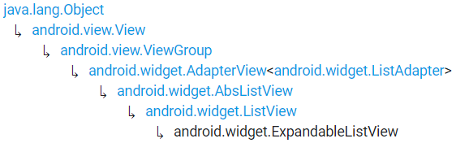

根据上图可知，ExpandableListView是ListView的子类，与ListView的区别在于，ExpandableListView对列表项进行了分组，每个分组中又可以显示具体的子项目。

使用说明：

1. 定义ExpandableListAdapter的子类MyExpandableListAdapter：

public class MyExpandableListAdapter extends BaseExpandableListAdapter {...}

1. 定义类中属性：

String[] mgroupstrings;

Context mcontext;

LayoutInflater minflater = null;

List<List<Item>> mdata = null;

1. 定义子列表内容的类Item：

class Item {

int image;

String card;

String price;}

1. 重载ExpandableListAdapter类中的方法：

*//获得父列表项的数目*

@Override

public int getGroupCount() { return mdata.size(); }

*//获得子列表项的数目*

@Override

public int getChildrenCount(int groupPosition) { return mdata.get(groupPosition).size(); }

*//获得父列表项*

@Override

public List<Item> getGroup(int groupPosition) { return mdata.get(groupPosition); }

*//获取子列表项对应的Item*

@Override

public Item getChild(int groupPosition, int childPosition) { return mdata.get(groupPosition).get(childPosition); }

*//获得父列表项的Id*

@Override

public long getGroupId(int groupPosition) { return groupPosition; }

*//获得子列表项的Id*

@Override

public long getChildId(int groupPosition, int childPosition) { return childPosition; }

*//子列表项是否能否触发事件，返回true则为可以响应点击*

@Override

public boolean isChildSelectable(int groupPosition, int childPosition) { return true; }

@Override

public boolean hasStableIds() { return true; }

*//获得子列表项*

public View getChildView(int groupPosition, int childPosition, boolean isLastChild, View convertView, ViewGroup parent) {

if (convertView == null)

convertView = minflater.inflate(R.layout.child, null);

*//子列表项的布局文件的View类，具体看下面的类定义*

ChildViewHolder holder = new ChildViewHolder();

holder.micon = (ImageView) convertView.findViewById(R.id.icon);

holder.micon.setBackgroundResource(getChild(groupPosition, childPosition).image);

holder.mchildname = (TextView) convertView.findViewById(R.id.card);

holder.mchildname.setText(getChild(groupPosition, childPosition).card);

holder.mprice = (TextView) convertView.findViewById(R.id.price);

holder.mprice.setText(getChild(groupPosition, childPosition).price);

return convertView;

}

*//获得父列表项，与getChildView方法类似*

public View getGroupView(int groupPosition, boolean IsExpanded, View convertView, ViewGroup parent) {

if (convertView == null)

convertView = minflater.inflate(R.layout.group, null);

GroupViewHolder holder = new GroupViewHolder();

holder.mgroupname = (TextView) convertView.findViewById(R.id.place);

holder.mgroupname.setText(mgroupstrings[groupPosition]);

return convertView;

}

全部完成后按步骤操作的运行截屏：

 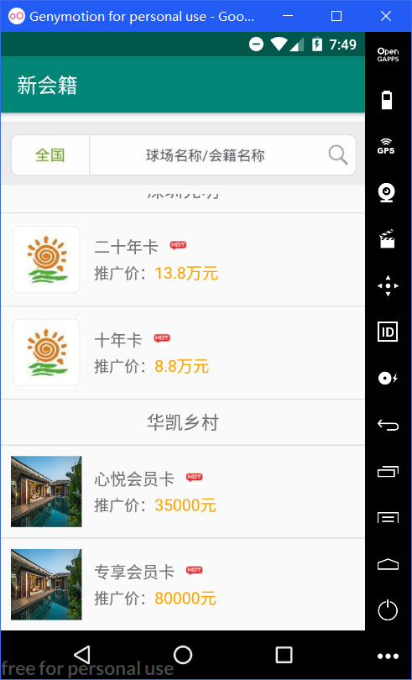 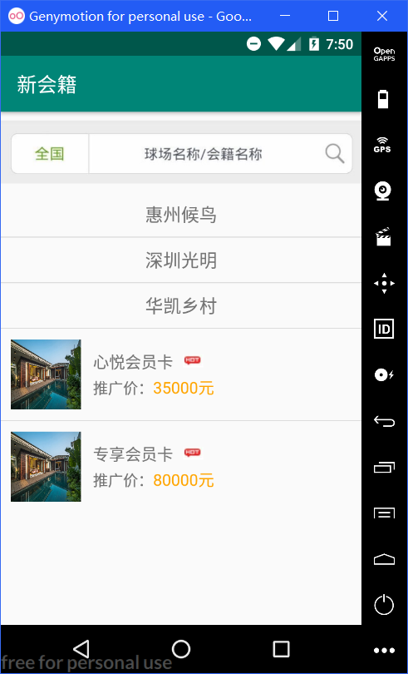

运行app 下拉后点开 华凯乡村 隐藏 惠州候鸟 和 深圳光明

全部完成后源码(.java和.xml)：

MainAcitivity.java：

package com.example.expandablelistview;

import android.os.SystemClock;

import android.support.v7.app.AppCompatActivity;

import android.os.Bundle;

import android.widget.ExpandableListView;

import java.util.ArrayList;

import java.util.List;

public class MainActivity extends AppCompatActivity {

String[] places = new String[] {"惠州候鸟", "深圳光明", "华凯乡村"};

String[][] cards = new String[][] {{"迎奥卡", "候鸟都市精英卡"}, {"二十年卡", "十年卡"}, {"心悦会员卡", "专享会员卡"}};

String[][] prices = new String[][] {{"29800元", "58000元"},{"13.8万元", "8.8万元"},{"35000元", "80000元"}};

int[] images = {R.drawable.huizhouhouniao, R.drawable.shenzhenguangming, R.drawable.huakaixiangcun};

ExpandableListView listView;

@Override

protected void onCreate(Bundle savedInstanceState) {

super.onCreate(savedInstanceState);

setContentView(R.layout.activity_main);

listView = (ExpandableListView) findViewById(R.id.list_view);

List<List<Item>> childdata = new ArrayList<>();

for (int i = 0; i < 3; ++i) {

List<Item> ccdata = new ArrayList<>();

for (int j = 0; j < 2; ++j) {

Item tmp = new Item();

tmp.card = cards[i][j];

tmp.image = images[i];

tmp.price = prices[i][j];

ccdata.add(tmp);

}

childdata.add(ccdata);

}

MyExpandableListAdapter adapter = new MyExpandableListAdapter(this, childdata, places);

listView.setAdapter(adapter);

listView.expandGroup(0);

listView.expandGroup(1);

}

}

MyExpandableListAdapter.java：

package com.example.expandablelistview;

import android.content.Context;

import android.view.LayoutInflater;

import android.view.View;

import android.view.ViewGroup;

import android.widget.BaseExpandableListAdapter;

import android.widget.ImageView;

import android.widget.TextView;

import java.util.List;

class Item {

int image;

String card;

String price;

}

public class MyExpandableListAdapter extends BaseExpandableListAdapter {

String[] mgroupstrings;

Context mcontext;

LayoutInflater minflater = null;

List<List<Item>> mdata = null;

private class GroupViewHolder { TextView mgroupname; }

private class ChildViewHolder {

ImageView micon;

TextView mchildname;

TextView mprice;

}

public MyExpandableListAdapter(Context context, List<List<Item>> list, String[] places){

mcontext = context;

mdata = list;

minflater = (LayoutInflater) mcontext.getSystemService(Context.LAYOUT_INFLATER_SERVICE);

mgroupstrings = places;

}

@Override

public int getGroupCount() { return mdata.size(); }

@Override

public int getChildrenCount(int groupPosition) { return mdata.get(groupPosition).size(); }

@Override

public List<Item> getGroup(int groupPosition) { return mdata.get(groupPosition); }

@Override

public Item getChild(int groupPosition, int childPosition) { return mdata.get(groupPosition).get(childPosition); }

@Override

public long getGroupId(int groupPosition) { return groupPosition; }

@Override

public long getChildId(int groupPosition, int childPosition) { return childPosition; }

@Override

public boolean isChildSelectable(int groupPosition, int childPosition) { return true; }

@Override

public boolean hasStableIds() { return true; }

public View getChildView(int groupPosition, int childPosition, boolean isLastChild, View convertView, ViewGroup parent) {

if (convertView == null)

convertView = minflater.inflate(R.layout.child, null);

ChildViewHolder holder = new ChildViewHolder();

holder.micon = (ImageView) convertView.findViewById(R.id.icon);

holder.micon.setBackgroundResource(getChild(groupPosition, childPosition).image);

holder.mchildname = (TextView) convertView.findViewById(R.id.card);

holder.mchildname.setText(getChild(groupPosition, childPosition).card);

holder.mprice = (TextView) convertView.findViewById(R.id.price);

holder.mprice.setText(getChild(groupPosition, childPosition).price);

return convertView;

}

public View getGroupView(int groupPosition, boolean IsExpanded, View convertView, ViewGroup parent) {

if (convertView == null)

convertView = minflater.inflate(R.layout.group, null);

GroupViewHolder holder = new GroupViewHolder();

holder.mgroupname = (TextView) convertView.findViewById(R.id.place);

holder.mgroupname.setText(mgroupstrings[groupPosition]);

return convertView;

}

}

acitivity_main.xml：

<?xml version="1.0" encoding="utf-8"?>

<RelativeLayout xmlns:android="http://schemas.android.com/apk/res/android"

android:layout_width="match_parent"

android:layout_height="match_parent">

<ImageView

android:layout_width="match_parent"

android:layout_height="80dp"

android:src="@drawable/top"

android:id="@+id/top"/>

<ExpandableListView

android:layout_width="match_parent"

android:layout_height="wrap_content"

android:layout_below="@id/top"

android:id="@+id/list_view"

android:groupIndicator="@null"/>

</RelativeLayout>

group.xml：

<?xml version="1.0" encoding="utf-8"?>

<LinearLayout xmlns:android="http://schemas.android.com/apk/res/android"

android:layout_width="match_parent"

android:layout_height="match_parent"

android:gravity="center_horizontal">

<TextView

android:layout_width="match_parent"

android:layout_height="wrap_content"

android:id="@+id/place"

android:textSize="18sp"

android:text="惠州候鸟"

android:gravity="center_horizontal|center_vertical"

android:padding="10dp"

android:layout_gravity="center_horizontal|center_vertical"/>

</LinearLayout>

child.xml：

<?xml version="1.0" encoding="utf-8"?>

<RelativeLayout xmlns:android="http://schemas.android.com/apk/res/android"

android:layout_width="match_parent"

android:layout_height="match_parent"

android:padding="10dp">

<ImageView

android:layout_width="70dp"

android:layout_height="70dp"

android:layout_alignParentLeft="true"

android:layout_centerVertical="true"

android:id="@+id/icon"/>

<LinearLayout

android:layout_width="wrap_content"

android:layout_height="wrap_content"

android:layout_toRightOf="@id/icon"

android:layout_alignTop="@id/icon"

android:orientation="vertical"

android:padding="10dp">

<LinearLayout

android:layout_width="wrap_content"

android:layout_height="wrap_content"

android:padding="2dp">

<TextView

android:layout_width="wrap_content"

android:layout_height="wrap_content"

android:id="@+id/card"

android:text="迎奥卡"

android:textSize="16sp"/>

<ImageView

android:layout_width="20dp"

android:layout_height="20dp"

android:layout_marginLeft="10dp"

android:id="@+id/hot"

android:src="@drawable/hot"/>

</LinearLayout>

<LinearLayout

android:layout_width="wrap_content"

android:layout_height="wrap_content"

android:padding="2dp">

<TextView

android:layout_width="wrap_content"

android:layout_height="wrap_content"

android:text="推广价："

android:textSize="15sp" />

<TextView

android:layout_width="wrap_content"

android:layout_height="wrap_content"

android:id="@+id/price"

android:textSize="16sp"

android:text="29800元"

android:textColor="@color/orange"/>

</LinearLayout>

</LinearLayout>

</RelativeLayout>

6、（选做）从网上查询CardView的资料后做一个CardView的使用说明和例程。

参考截屏：

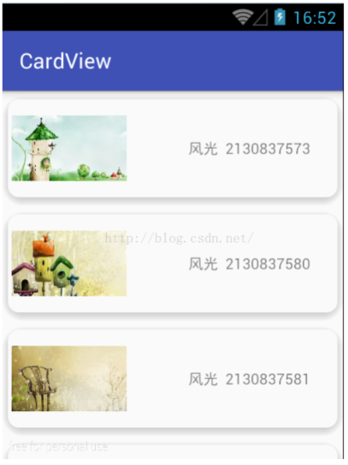

控件功能说明：

CardView是Android 5.0系统引入的控件，相当于FragmentLayout布局控件然后添加圆角及阴影的效果；CardView被包装为一种布局，并且经常在ListView和RecyclerView的Item布局中，作为一种容器使用。CardView应该在显示层次性的内容时被使用，在显示列表或网格时更应该被选择。

继承：

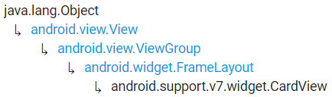

控件使用说明：

属性：

1. app:cardBackgroundColor-- 背景色
2. app:cardCornerRadius-- 边缘弧度数
3. app:cardElevation-- 高度
4. app:cardMaxElevation-- 最大高度
5. app:cardUseCompatPadding-- 设置内边距
6. app:cardPreventCornerOverlap-- 添加内边距，这个属性是为了防止卡片内容和边角的重叠
7. app:contentPadding-- 卡片边界距离内部的距离
8. app:contentPaddingLeft-- 卡片边界距离左边的距离
9. app:contentPaddingTop-- 卡片边界距离顶边的距离
10. app:contentPaddingRight-- 卡片边界距离右边的距离
11. app:contentPaddingBottom-- 卡片边界距离底边的距离

分布图：

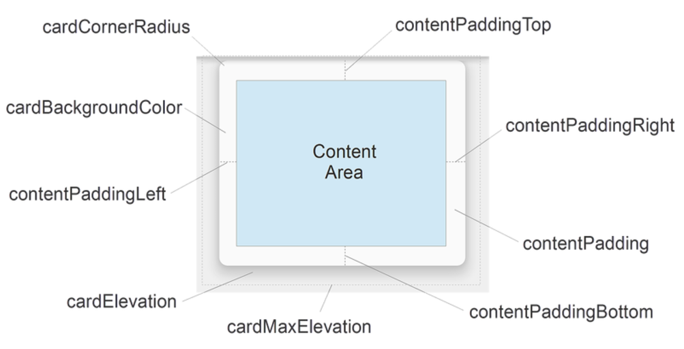

全部完成后按步骤操作的运行截屏：

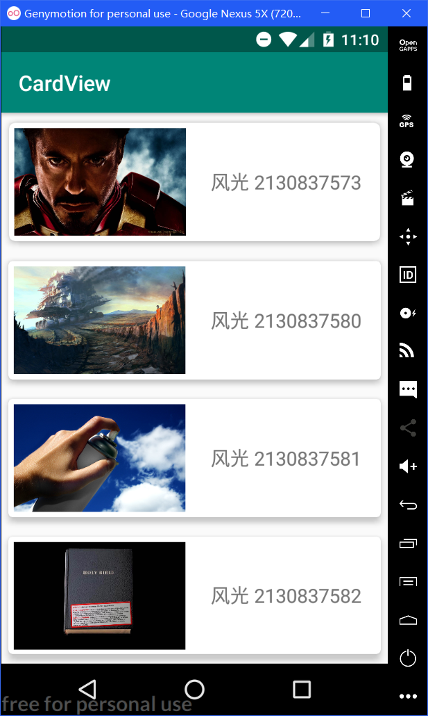

全部完成后源码(.java和.xml)：

MainAcitivity.java：

package com.example.cardview;

import android.support.v7.app.AppCompatActivity;

import android.os.Bundle;

public class MainActivity extends AppCompatActivity {

@Override

protected void onCreate(Bundle savedInstanceState) {

super.onCreate(savedInstanceState);

setContentView(R.layout.activity_main);

}

}

activity_main.xml：

<?xml version="1.0" encoding="utf-8"?>

<LinearLayout xmlns:android="http://schemas.android.com/apk/res/android"

xmlns:app="http://schemas.android.com/apk/res-auto"

xmlns:tools="http://schemas.android.com/tools"

android:layout_width="match_parent"

android:layout_height="match_parent"

android:orientation="vertical"

tools:context=".MainActivity">

<android.support.v7.widget.CardView

android:layout_width="match_parent"

android:layout_height="wrap_content"

android:id="@+id/cardview1"

app:cardCornerRadius="6dp"

app:cardElevation="5dp"

app:cardMaxElevation="5dp"

app:cardPreventCornerOverlap="true"

app:cardUseCompatPadding="true">

<LinearLayout

android:layout_width="match_parent"

android:layout_height="wrap_content">

<ImageView

android:layout_width="160dp"

android:layout_height="100dp"

android:layout_margin="5dp"

android:src="@drawable/image5"/>

<TextView

android:layout_width="match_parent"

android:layout_height="match_parent"

android:text="风光 2130837573"

android:textSize="18sp"

android:gravity="center"/>

</LinearLayout>

</android.support.v7.widget.CardView>

<android.support.v7.widget.CardView

android:layout_width="match_parent"

android:layout_height="wrap_content"

android:id="@+id/cardview2"

app:cardCornerRadius="4dp"

app:cardElevation="5dp"

app:cardMaxElevation="5dp"

app:cardPreventCornerOverlap="true"

app:cardUseCompatPadding="true">

<LinearLayout

android:layout_width="match_parent"

android:layout_height="wrap_content">

<ImageView

android:layout_width="160dp"

android:layout_height="100dp"

android:layout_margin="5dp"

android:src="@drawable/image2"/>

<TextView

android:layout_width="match_parent"

android:layout_height="match_parent"

android:text="风光 2130837580"

android:textSize="18sp"

android:gravity="center"/>

</LinearLayout>

</android.support.v7.widget.CardView>

<android.support.v7.widget.CardView

android:layout_width="match_parent"

android:layout_height="wrap_content"

android:id="@+id/cardview3"

app:cardCornerRadius="4dp"

app:cardElevation="5dp"

app:cardMaxElevation="5dp"

app:cardPreventCornerOverlap="true"

app:cardUseCompatPadding="true">

<LinearLayout

android:layout_width="match_parent"

android:layout_height="wrap_content">

<ImageView

android:layout_width="160dp"

android:layout_height="100dp"

android:layout_margin="5dp"

android:src="@drawable/image3"/>

<TextView

android:layout_width="match_parent"

android:layout_height="match_parent"

android:text="风光 2130837581"

android:textSize="18sp"

android:gravity="center"/>

</LinearLayout>

</android.support.v7.widget.CardView>

<android.support.v7.widget.CardView

android:layout_width="match_parent"

android:layout_height="wrap_content"

android:id="@+id/cardview4"

app:cardCornerRadius="4dp"

app:cardElevation="5dp"

app:cardMaxElevation="5dp"

app:cardPreventCornerOverlap="true"

app:cardUseCompatPadding="true">

<LinearLayout

android:layout_width="match_parent"

android:layout_height="wrap_content">

<ImageView

android:layout_width="160dp"

android:layout_height="100dp"

android:layout_margin="5dp"

android:src="@drawable/image4"/>

<TextView

android:layout_width="match_parent"

android:layout_height="match_parent"

android:text="风光 2130837582"

android:textSize="18sp"

android:gravity="center"/>

</LinearLayout>

</android.support.v7.widget.CardView>

</LinearLayout>

【完成情况】

是否完成了这些实验题目？√完成 ×未做，x%--未完成(已完成比例)

1 [√] 2 [√] 3[√]

4(1)[√] 4(2)[√] 4(3)[√] 4(4)[√]

5[√] 6[√]

【实验体会】

这是我第一次编写Android程序，感受可谓五味陈杂，尤其是做第一个“Register”的时候，由原本什么都不怎么太明白，通过自己慢慢看书，看ppt，在网上查找资料，最终还将第一个做了出来，这花了我整整一天的时间。不过有了做完第一个的经验，做第二个时候就不是什么大困难了。

在做第三个的时候，我发现一个很神奇的地方，就是设置秒表格式的时候，我将其设置为默认格式，而并不是参考“String.format("%02d:02d",i,j)”，显示效果竟然一模一样，我想这可能和我的Android Studio的版本有关吧，我装的是最新版，而老师推荐的是2.2版，我想这应该无伤大雅。

在做第四个计算器的时候，由于要求用的是线性布局，所以在设计布局的的时候，大部分的工作是重复的，但我觉得这个计算器最大的难点在于它的运行逻辑，要完全模仿windows下的计算器还是比较复杂的。

在做第五个ExpandableListView的时候，我原本打算使用SimpleExpandableListAdapter，但实现后运行发现它只能显示父级列表，当我想点开父级列表显示子级列表时，app突然就崩溃了，在debug无果之后，我最终选择较为复杂的BaseExpandableListAdapter，最终的效果也比较满意。

在做第六个CardView的时候，需要引入v7包，我在网上查找资料，发现需要在build.gradle文件中加入

dependencies {

implementation 'com.android.support:appcompat-v7:27.1.1'

compile "com.android.support:cardview-v7:27.1.1"

}

结果显示错误：

ERROR: Could not find method complie() for arguments [com.android.support:cardview-v7:27.1.1] on object of type org.gradle.api.internal.artifacts.dsl.dependencies.DefaultDependencyHandler.

Please install the Android Support Repository from the Android SDK Manager.

然而我已经安装了Android Support Repository，问题不在这个地方，经过几番查找资料后，我终于发现问题的关键所在：由于gradle的版本问题，它不支持compile指令，而应使用api指令。所以只需将compile改为api就可以解决这个问题。